**SPLUNK**

**Splunk Beginner to Architect**

**Section 1: Splunk Architecture:**

1. **Directory Structure of Splunk - New:**

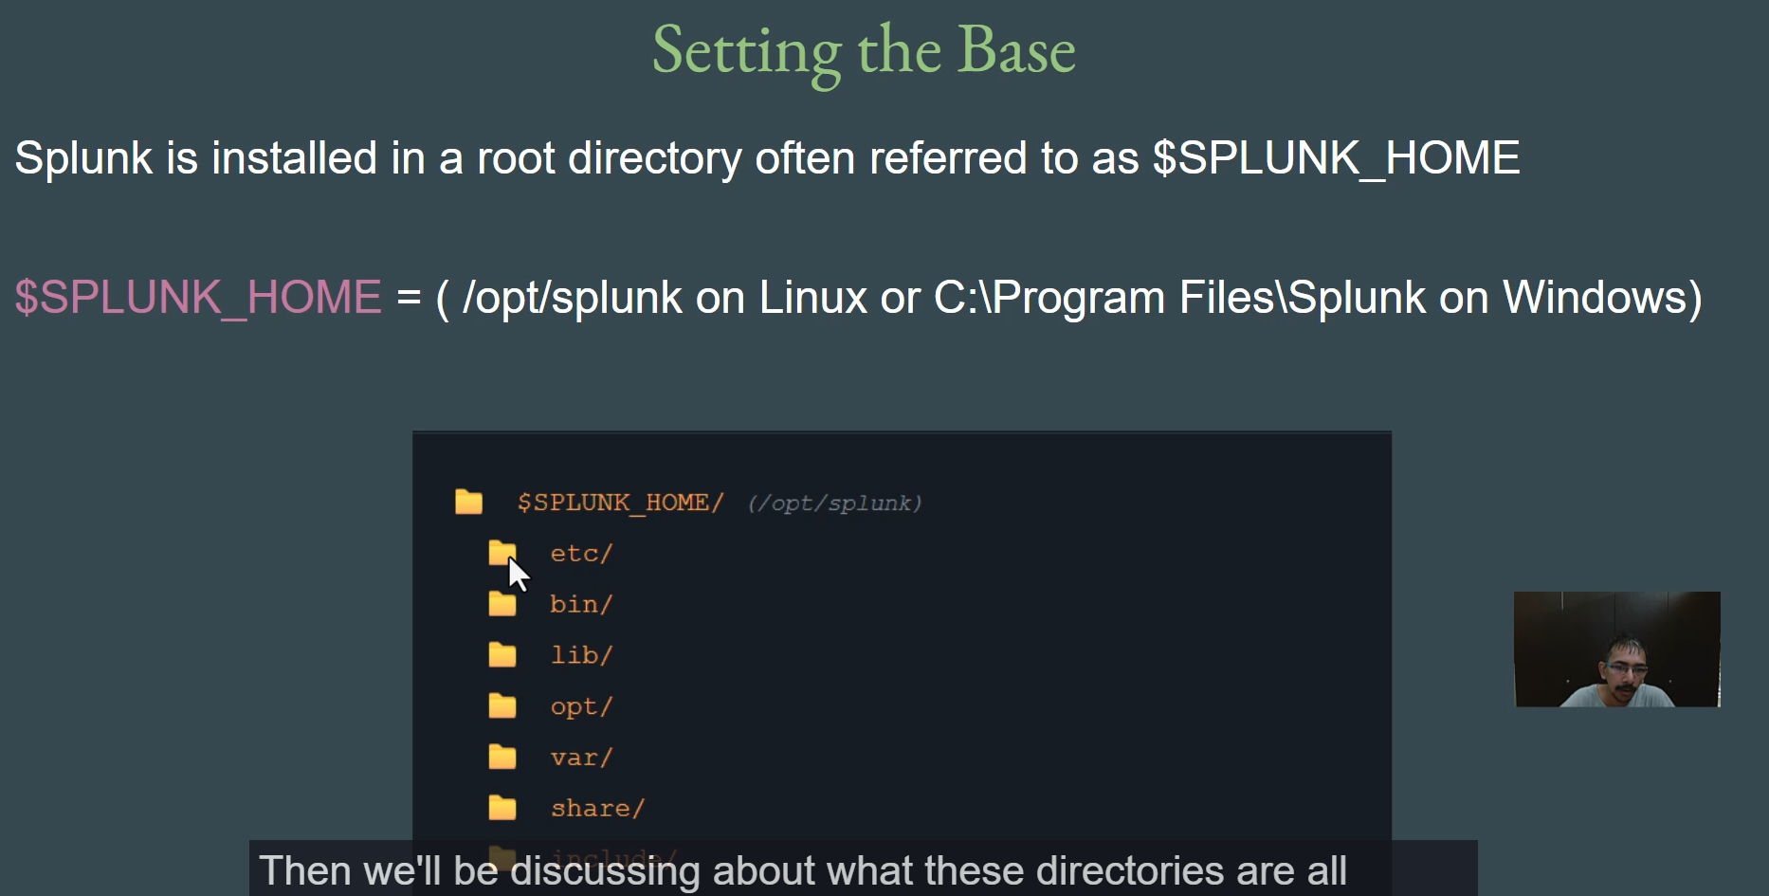

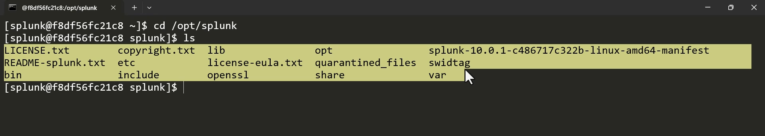

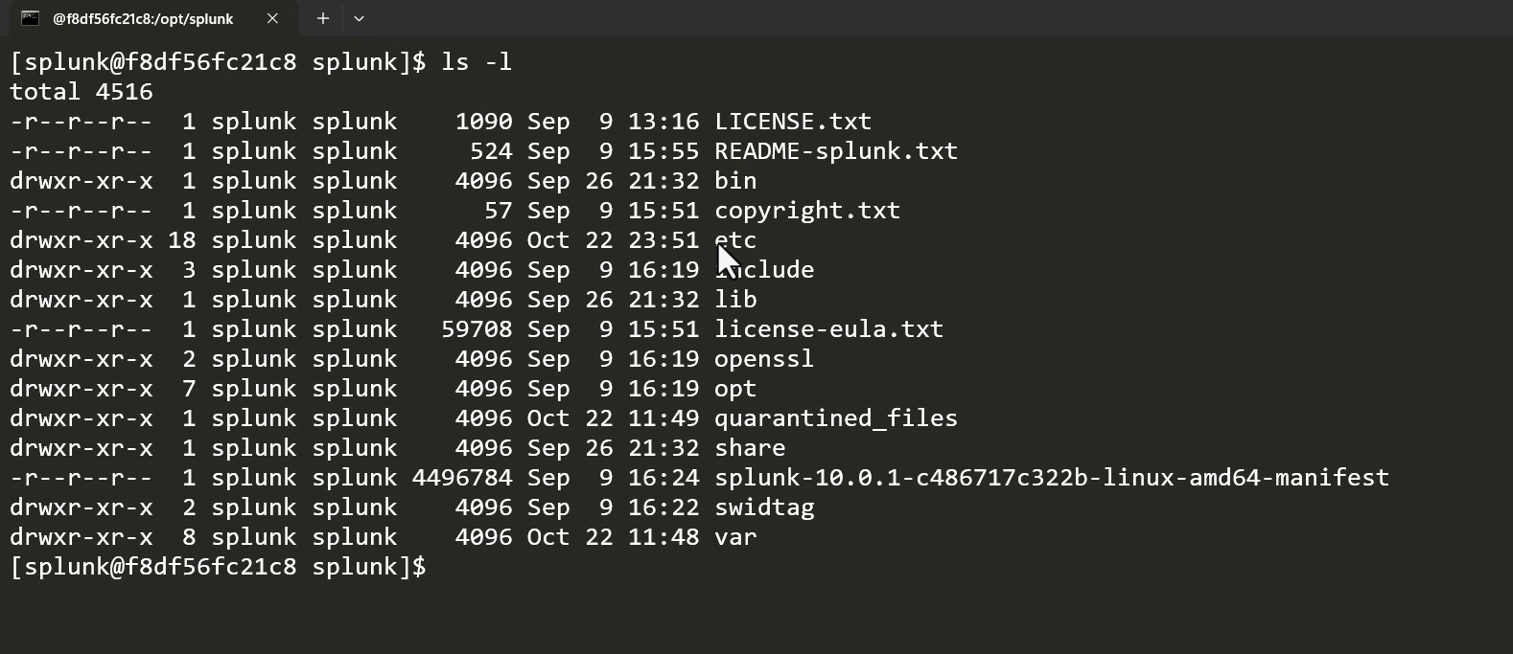

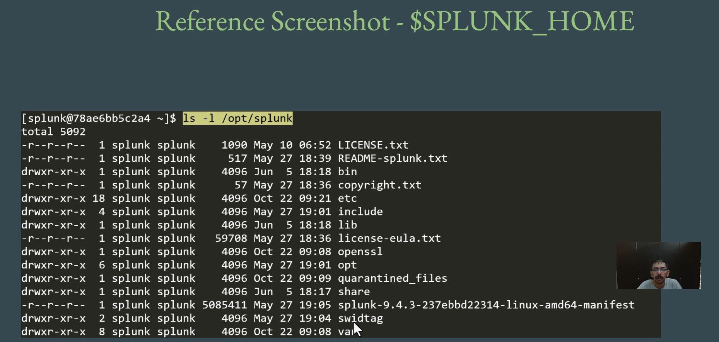

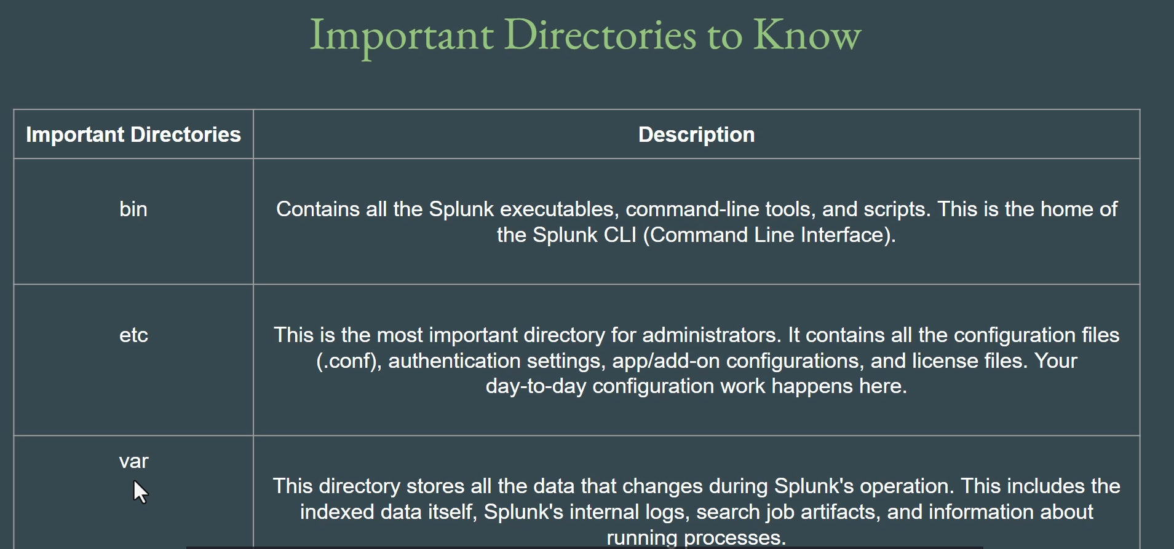

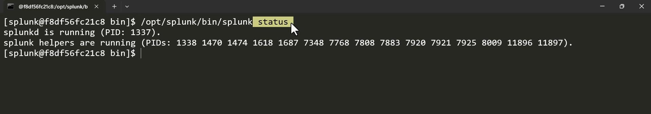

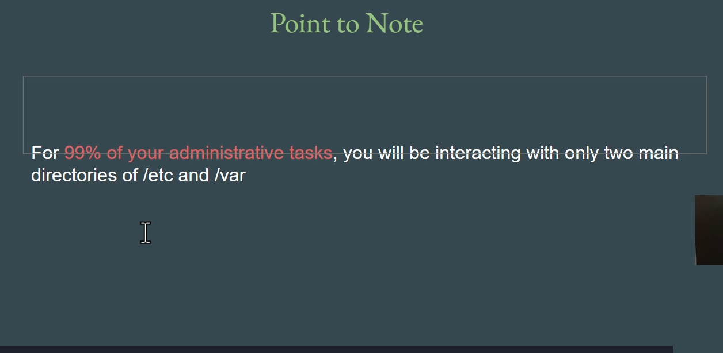

**Splunk Directory Structure Summary**

This video emphasizes that understanding the **Splunk directory structure** is crucial for administrative tasks, configurations, troubleshooting, and overall proficiency throughout one's Splunk journey.

**1. Splunk Home (Root Directory)**

* **Definition:** Everything starts with the **Splunk Home** variable, which represents the **root installation directory** of Splunk.
* **Platform Dependency:** The value of the Splunk Home variable changes based on the Operating System (OS) where Splunk is installed:
  + **Linux:** Typically /opt/splunk.
  + **Windows:** Typically C:\Program Files\Splunk.
* **Directory Consistency:** The directory structure *inside* Splunk Home is **similar across all operating systems** (Linux, Windows, etc.).

**2. Linux Directory Structure Overview (Context)**

* The video briefly uses the standard Linux root directory structure (like /bin, /boot, /etc, /home) as a parallel to introduce the concept of specialized folders:
  + /bin: Contains general Linux binaries (e.g., ls, cd).
  + /etc: Contains Linux configuration files.

**3. Three Most Important Splunk Directories**

The Splunk directory structure inside Splunk Home contains several folders (bin, etc, lib, opt, share, var, etc.), but **three** are most important for regular administrative interaction:

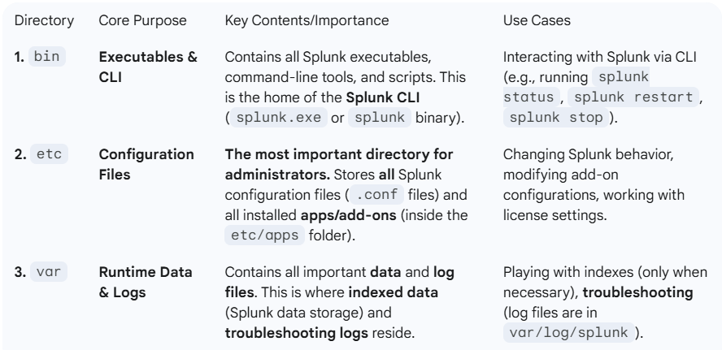

**4. Detailed Exploration of Key Directories**

**A. bin (Binaries)**

* The essential binary is **splunk** (or splunk.exe on Windows), which is used to run control commands like status, start, stop, and restart.

**B. etc (Configuration)**

* Contains the **apps** folder, which houses all installed apps (e.g., Apache, Nginx, Linux apps).
* Contains the **system** folder, which holds critical system-wide configuration files (e.g., authentication settings).
* Configuration files can often be modified directly via the Splunk GUI, but for many advanced changes, administrators must **directly edit the .conf files** via the CLI and then restart Splunk.

**C. var (Data and Logs)**

* **Indexed Data Storage:** Contains the indexed data in the var/lib/splunk/defaultdb/db path. It is **critical not to modify** files here unless absolutely necessary, as it can corrupt or lose data.
  + *Demonstration:* The video shows navigating to a raw data file (e.g., .../var/lib/splunk/defaultdb/db/hot/rawdata/0) to view the actual indexed events ("Hello world one," etc.).
* **Log Files for Troubleshooting:** Contains Splunk's own log files in the **var/log/splunk** directory.
  + The **splunkd.log** file is especially important for troubleshooting issues like Splunk not starting or not behaving as expected.

**5. Conclusion**

* For **99% of administrative tasks**, one will primarily interact with **etc** (for configuration) and **var** (for indexes/data and troubleshooting logs).
* The **bin** directory is used specifically for controlling the Splunk service (start/stop/restart) via the CLI.

===================================================================================

1. **Splunk Configuration Precedence:**

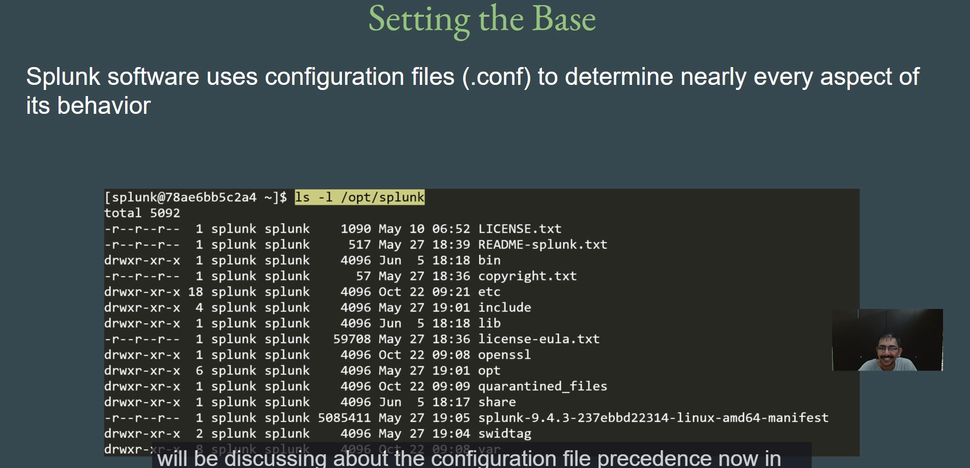

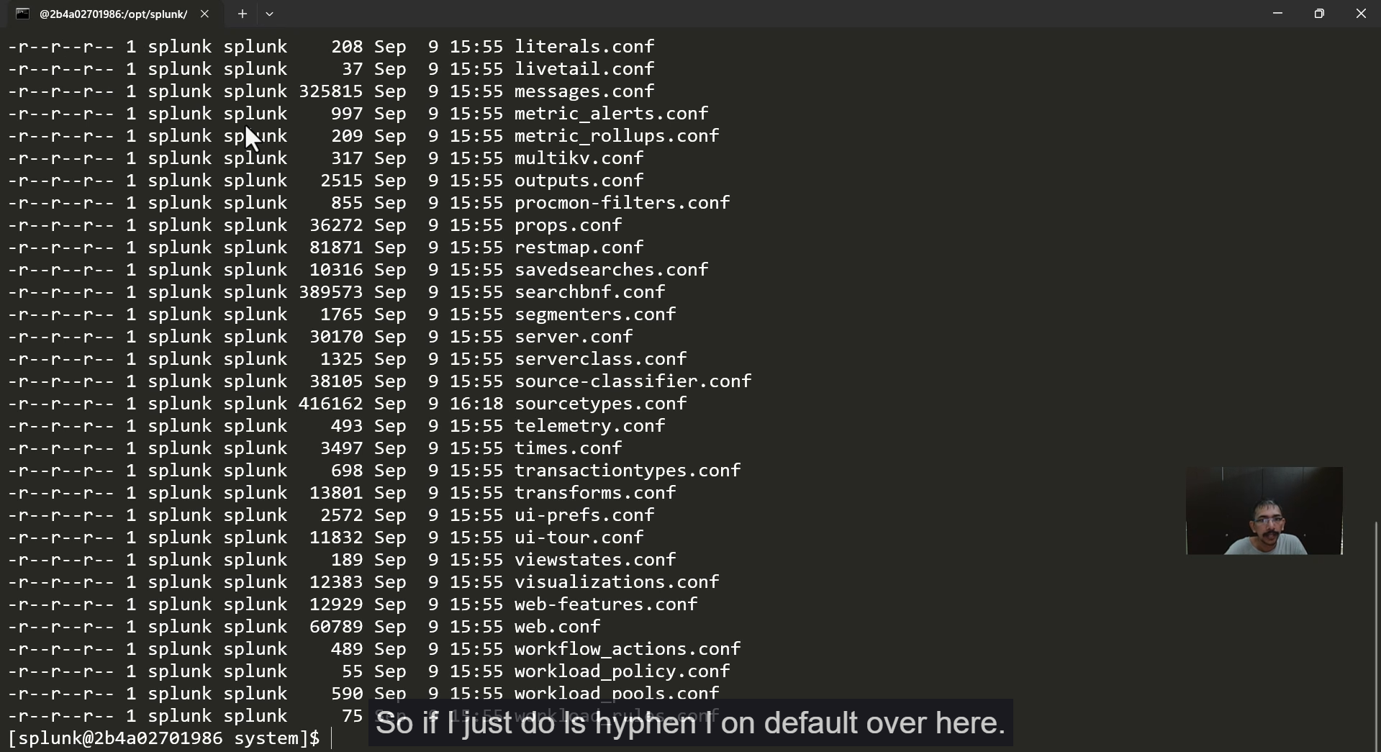

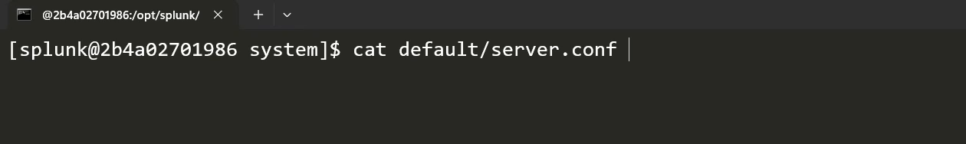

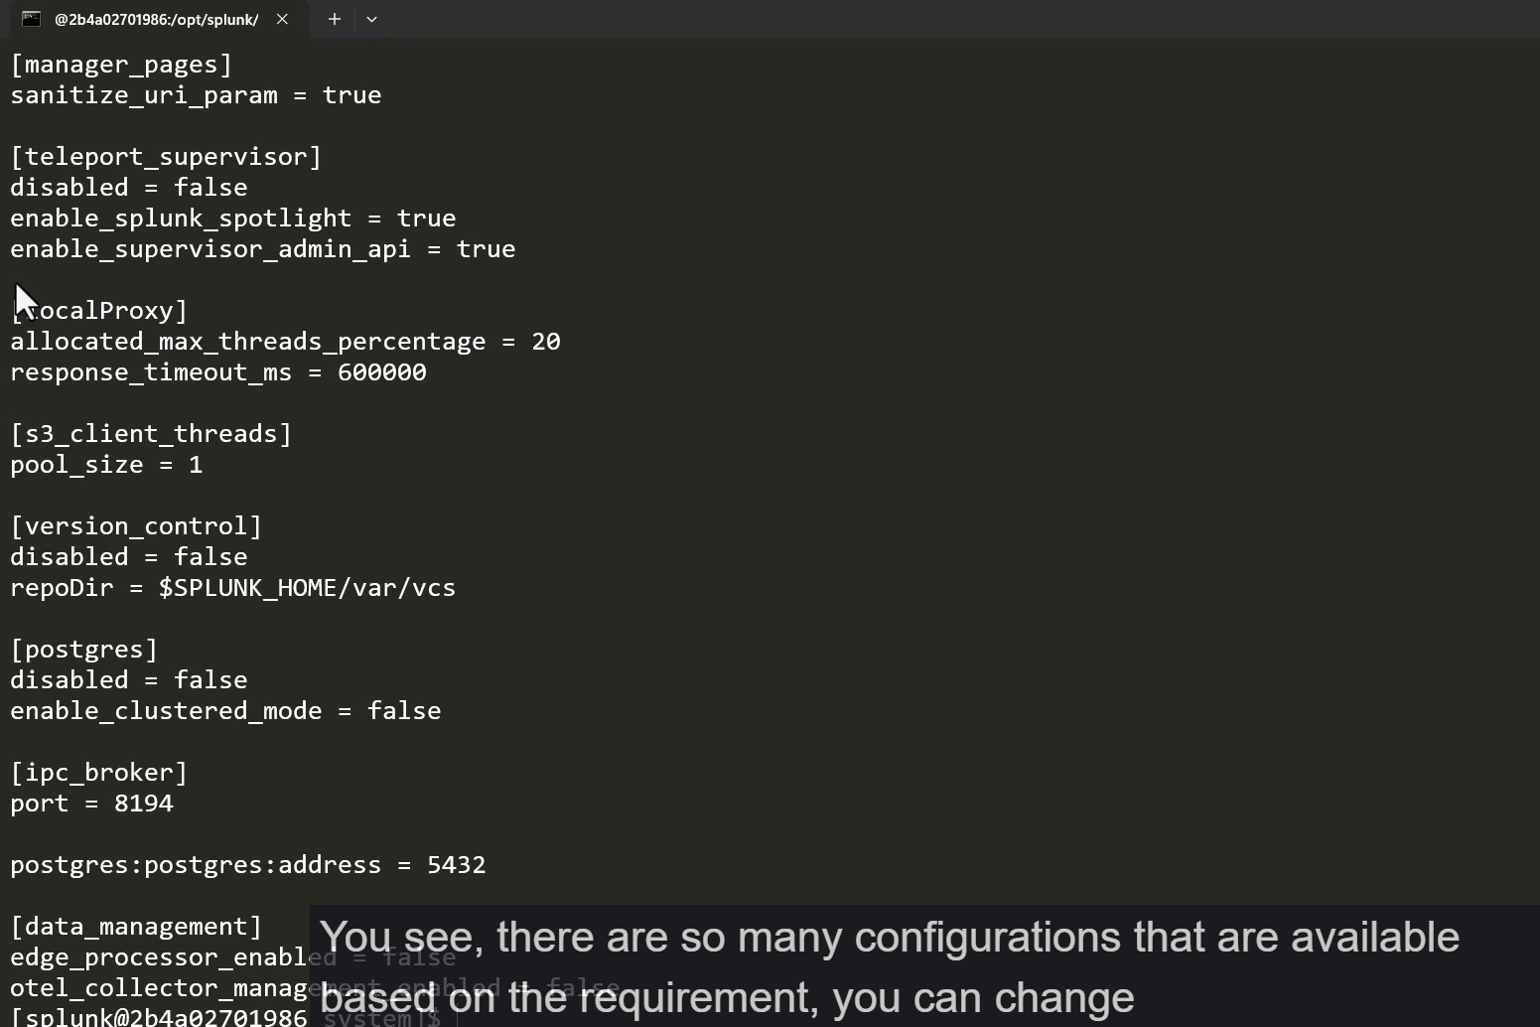

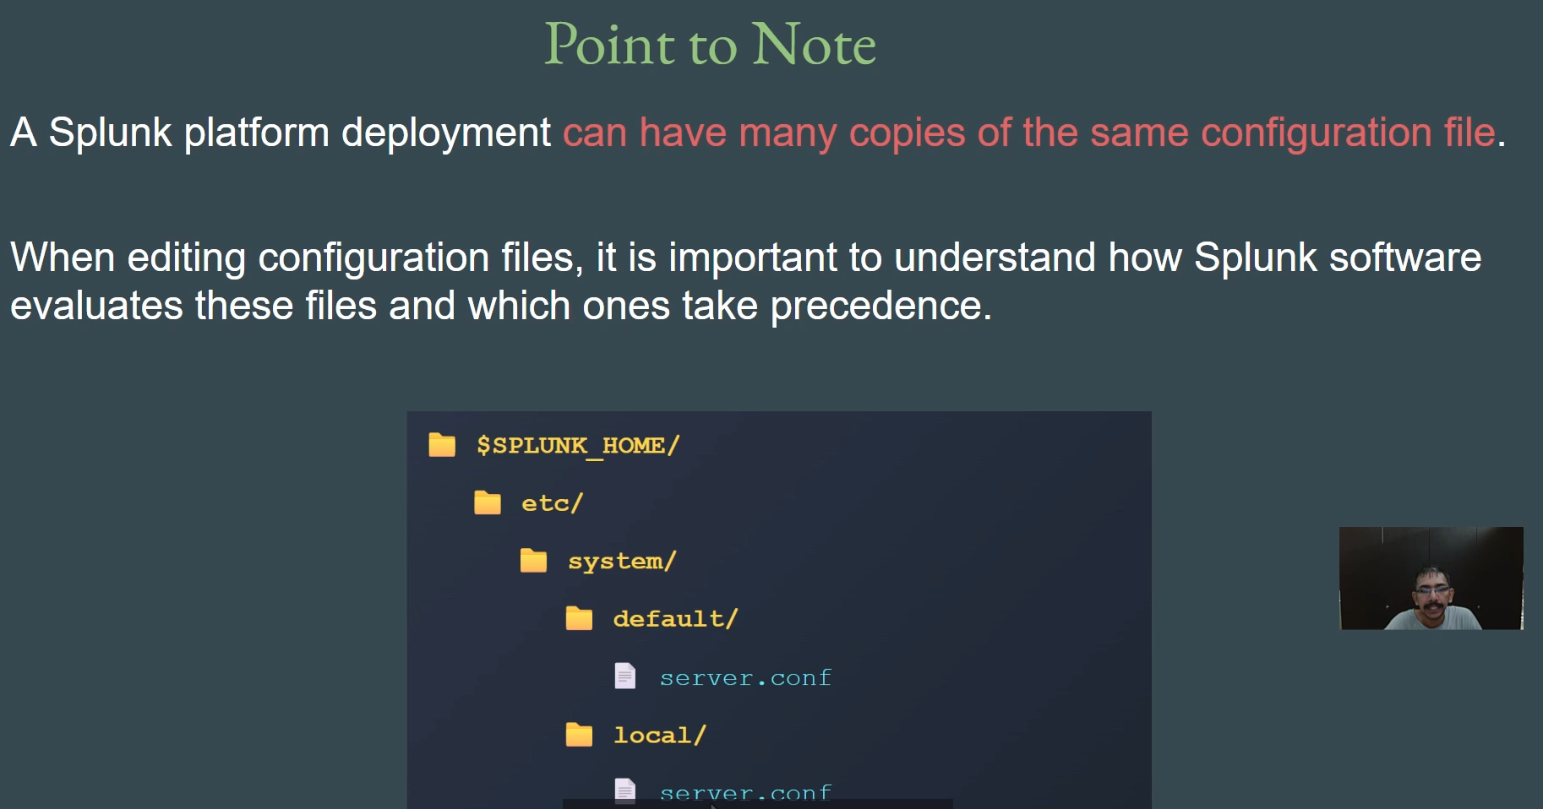

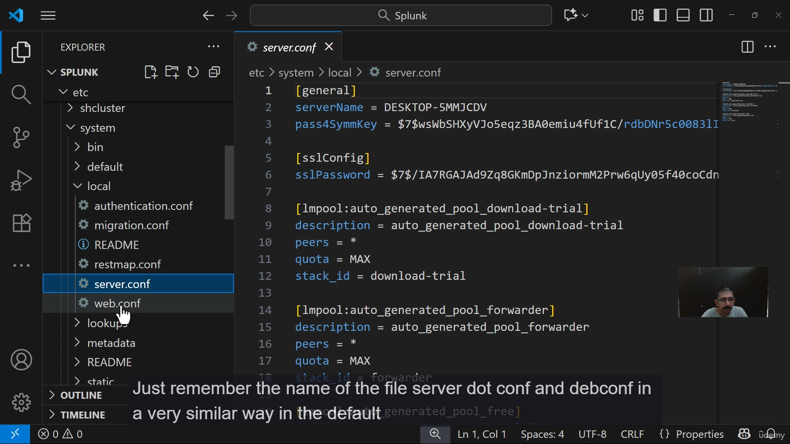

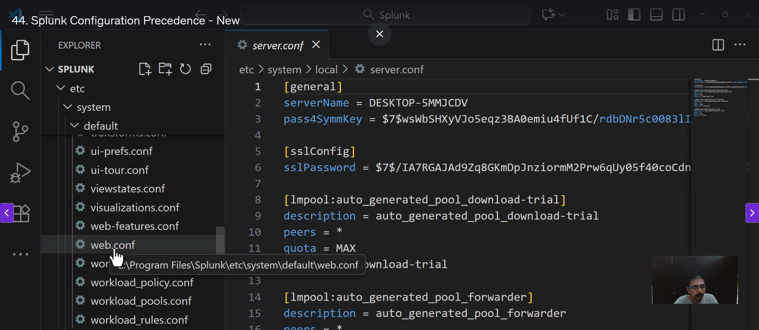

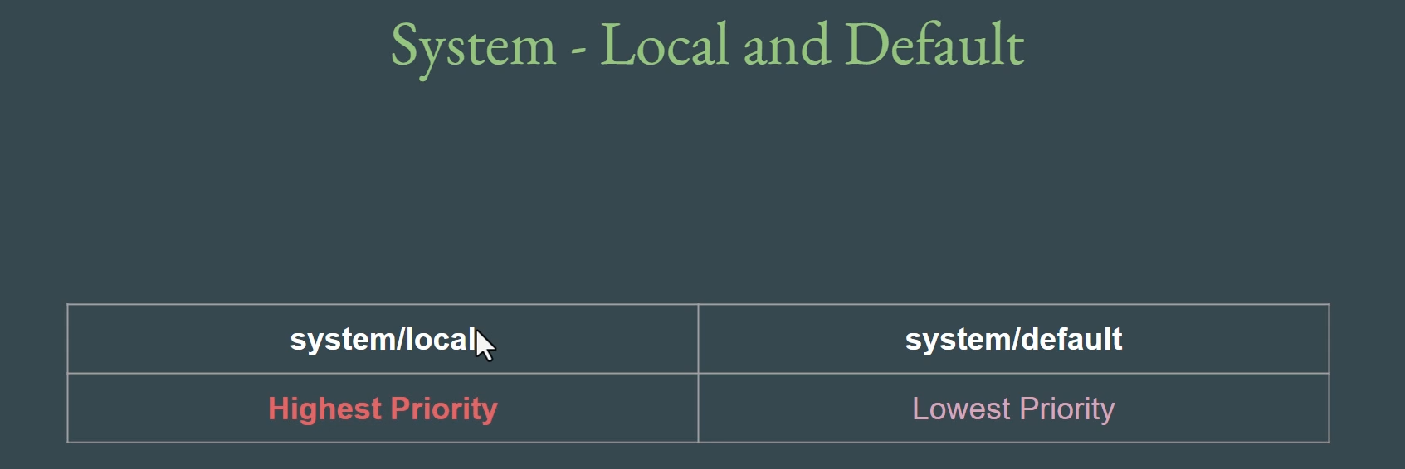

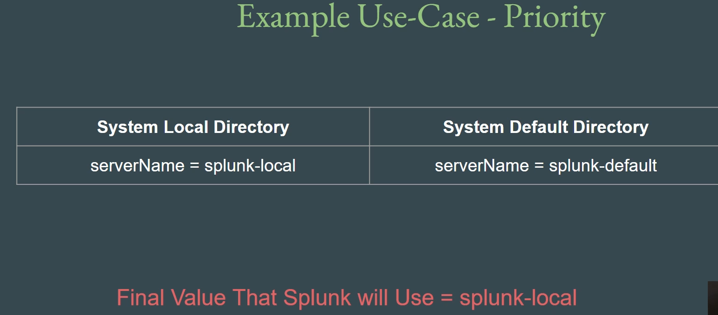

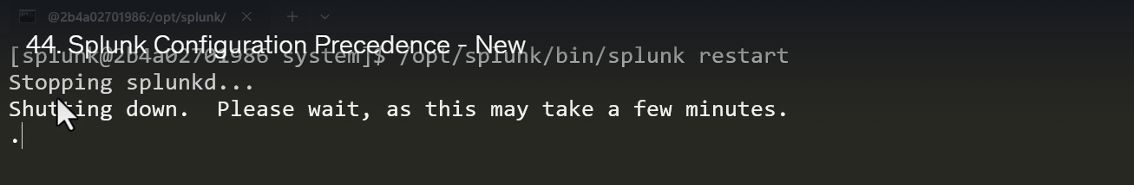

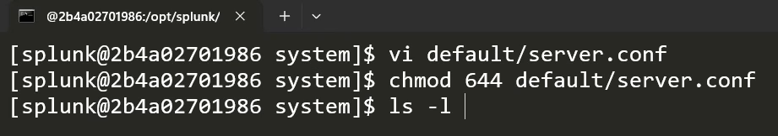

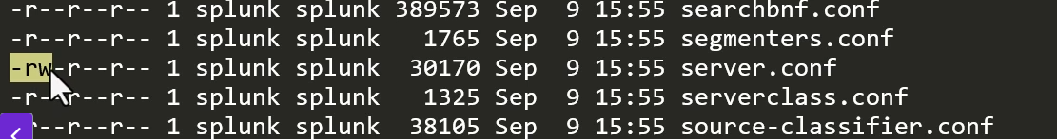

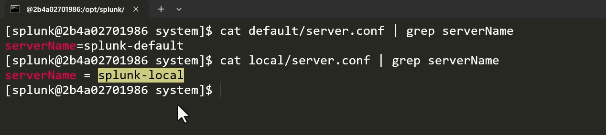

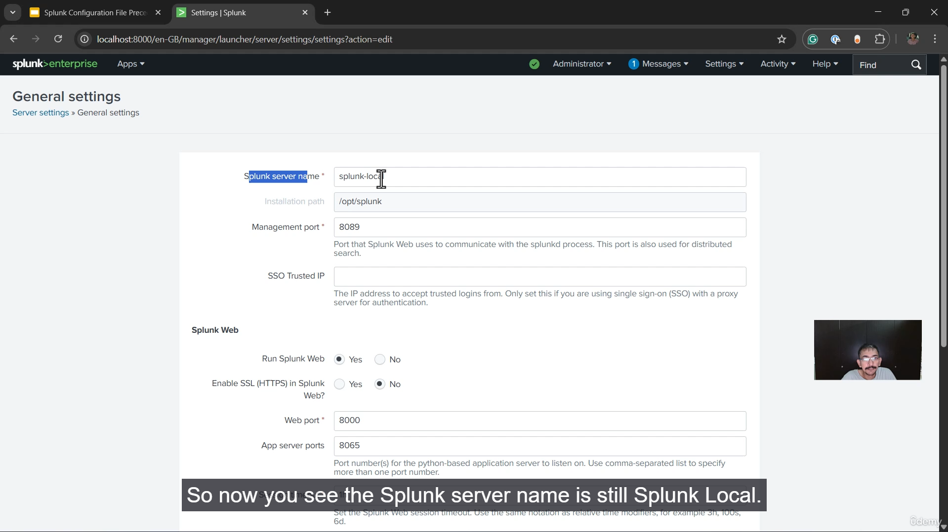

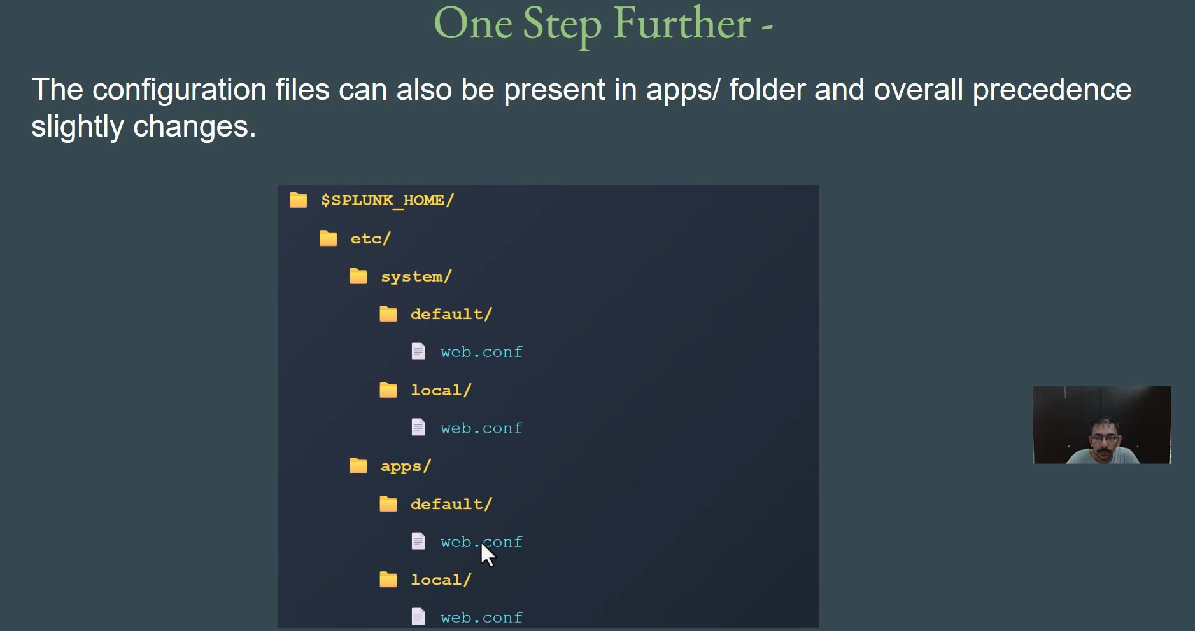

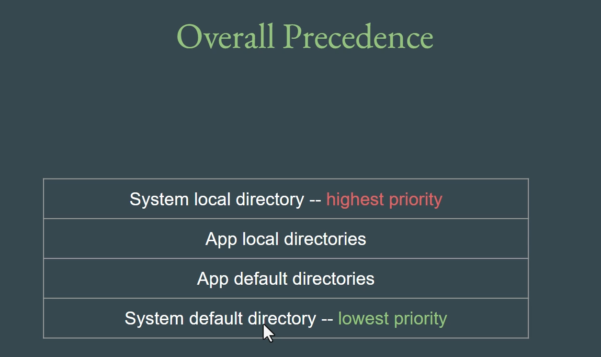

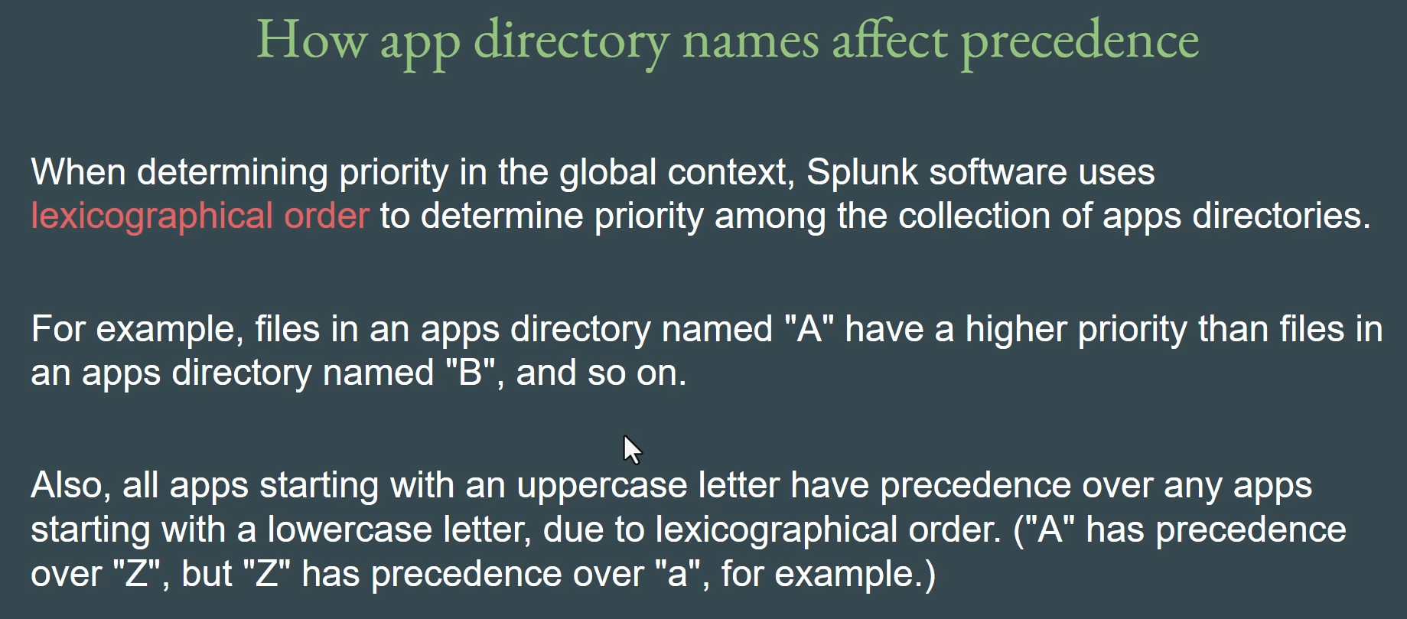

That was a very detailed and important explanation of configuration file precedence in Splunk.

Here is the summary of the transcript in bullet points, ensuring the original content is preserved and clarity is maintained:

**⚙️ Splunk Configuration File Precedence Summary**

**Core Concepts**

* **Configuration Files:** Splunk's behavior is determined by configuration files, which primarily end with the extension **.conf**.
* **Primary Location:** All configuration files are primarily stored in the **$SPLUNK_HOME/etc/** folder (e.g., opt/splunk/etc in Linux).
* **Multiple Copies:** A Splunk deployment can have **many copies** of the **same configuration file** (e.g., server.conf) stored in multiple directories.
* **The Precedence Question:** When multiple copies of the same file exist with different settings, **precedence** determines which configuration value Splunk will use.

**Key Directory Hierarchy**

The two core directories for configuration files within $SPLUNK_HOME/etc/system/ are:

* **default/**: Contains the **default** configuration files provided by Splunk.
* **local/**: Contains **user-defined** configurations and overrides.

**Local vs. Default Precedence**

* **local/ takes the Highest Priority:** The configuration files in the local/ directory will **always override** the same files in the default/ directory.
  + *Example:* If server.conf in system/local sets servername = Splunk Local and server.conf in system/default sets servername = Splunk Default, Splunk will use **Splunk Local**.
* **Best Practice: Never Edit default/:**
  + **Do not modify** configuration files in the default/ folder.
  + Changes made to default/ files will be **lost on update/upgrade** of Splunk.
  + Always make modifications in the **local/** folder to safely override settings, as the local/ files are not touched during an upgrade.
* **Default File Permissions:** By default, files in the default/ directory have read-only permissions (444) as a safeguard to prevent accidental user modifications.

**Extended Precedence (Including Apps)**

Configuration files can also exist within the **$SPLUNK_HOME/etc/apps/** folder (when apps or add-ons are installed). This introduces a more complex precedence order:

1. **System Local** ($SPLUNK_HOME/etc/system/local/) - **Highest Priority**
2. **App Local** ($SPLUNK_HOME/etc/apps/<appname>/local/)
3. **App Default** ($SPLUNK_HOME/etc/apps/<appname>/default/)
4. **System Default** ($SPLUNK_HOME/etc/system/default/) - **Lowest Priority**

**App Directory Precedence**

When multiple apps have configuration files that conflict (e.g., multiple apps contain their own web.conf):

* Splunk uses **lexicographical order** (alphabetical order) to determine the priority among the **app directories**.
* An app directory named **'A'** will have higher precedence than an app directory named **'B'**.
* **Case Sensitivity:** App names starting with an **uppercase letter** have higher precedence than those starting with a **lowercase letter** (e.g., 'Z' has precedence over 'a').

===================================================================================

1. **Introduction to Indexes:**

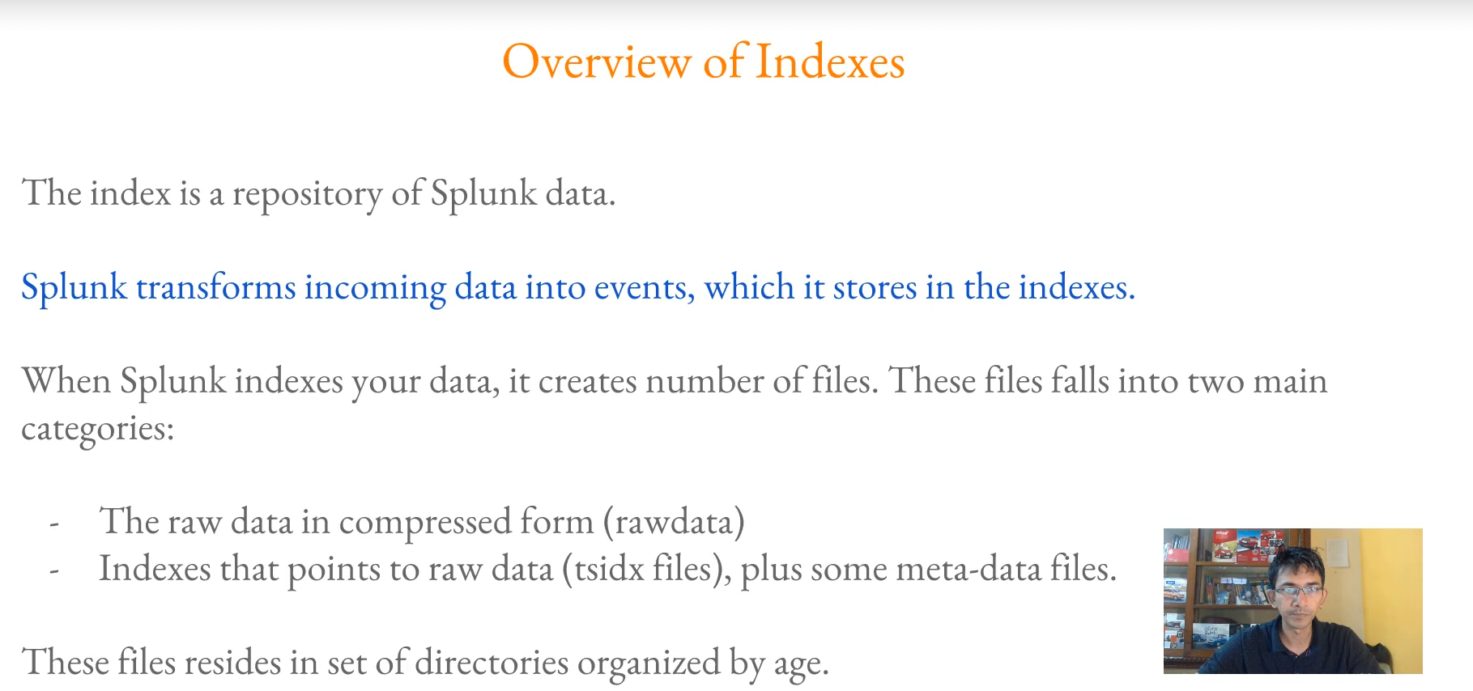

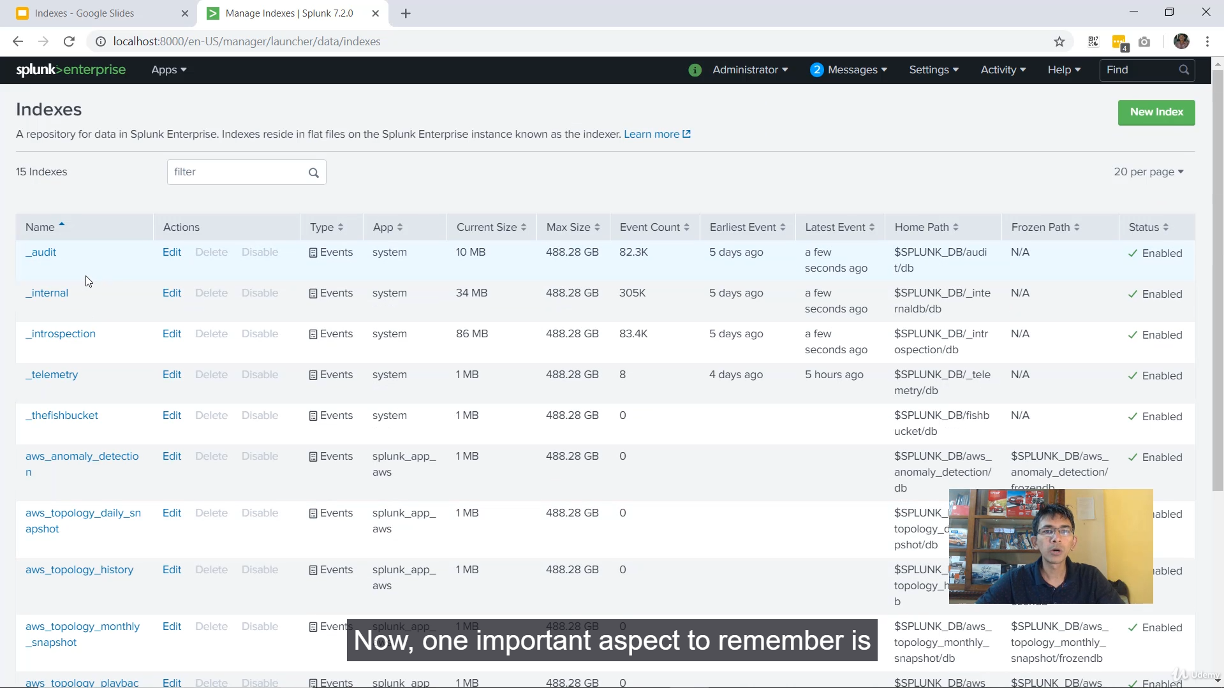

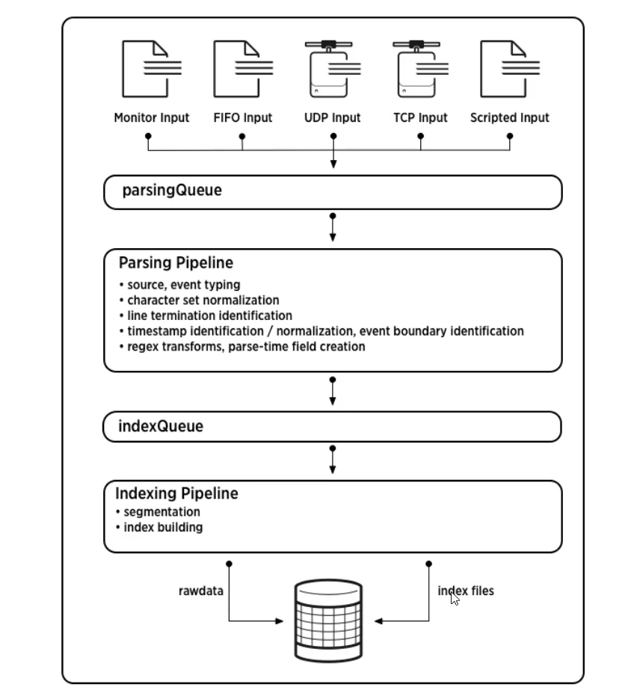

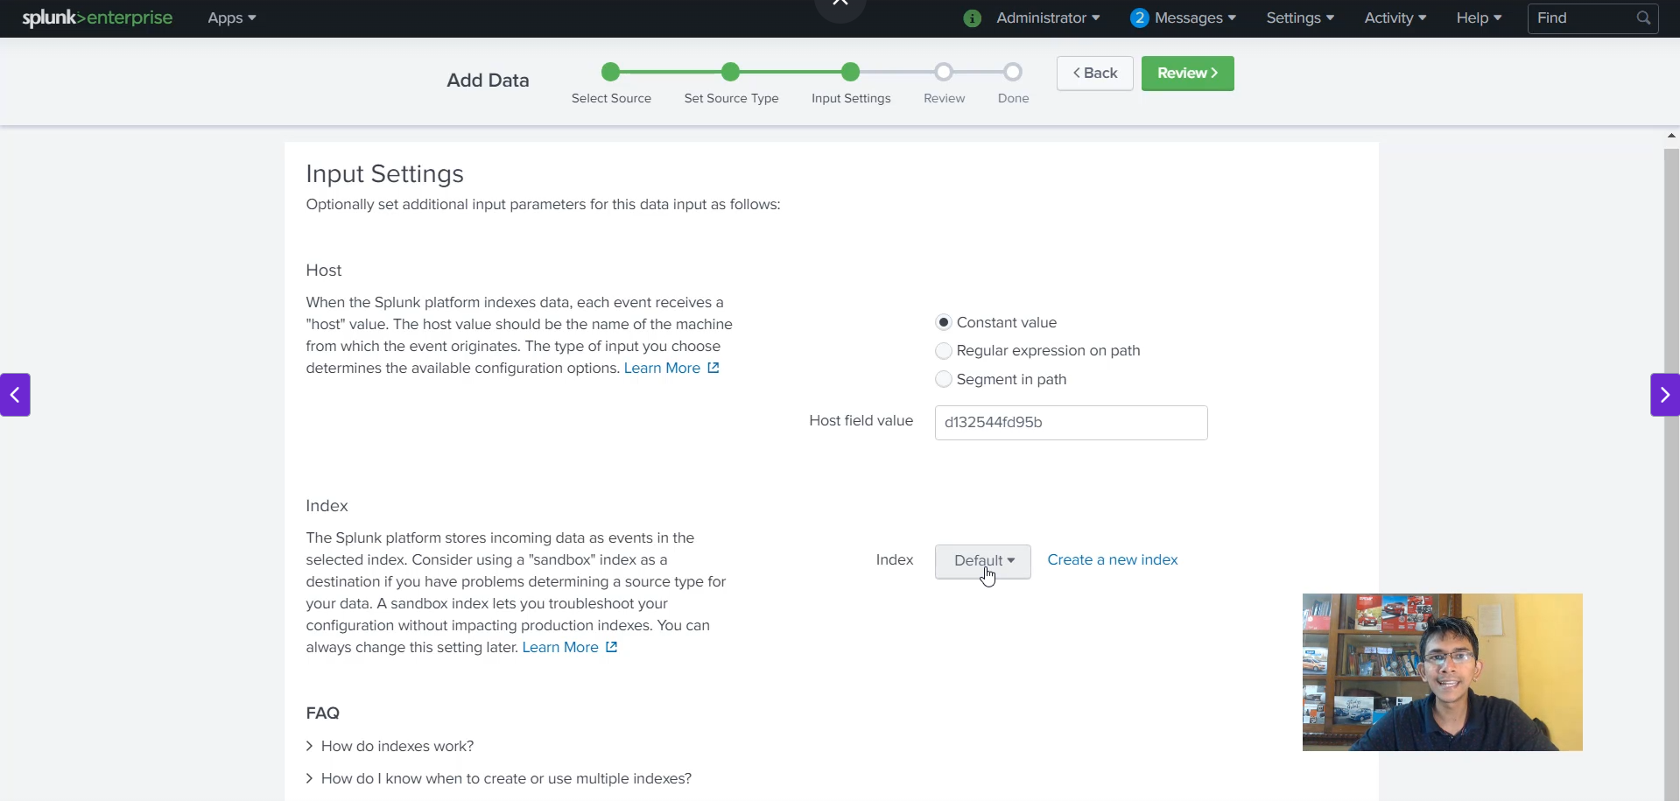

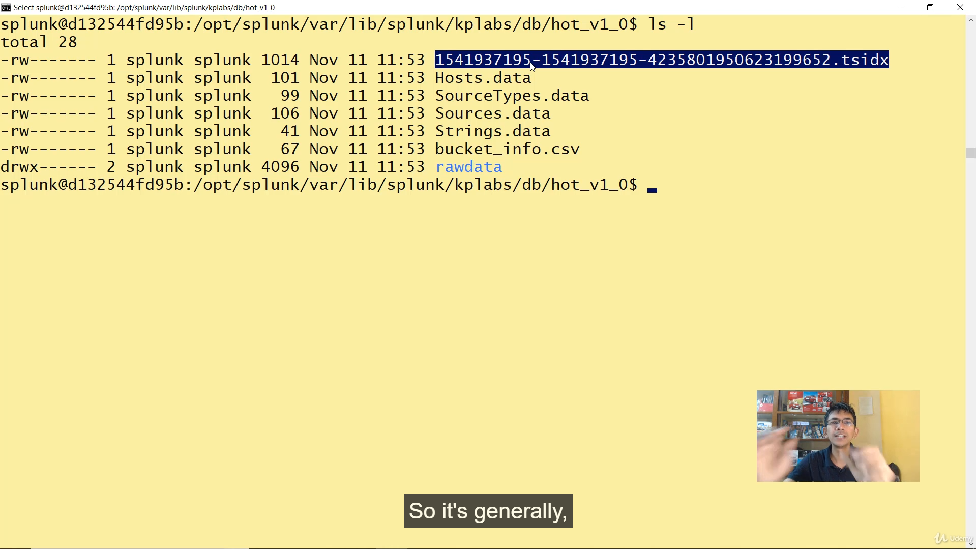

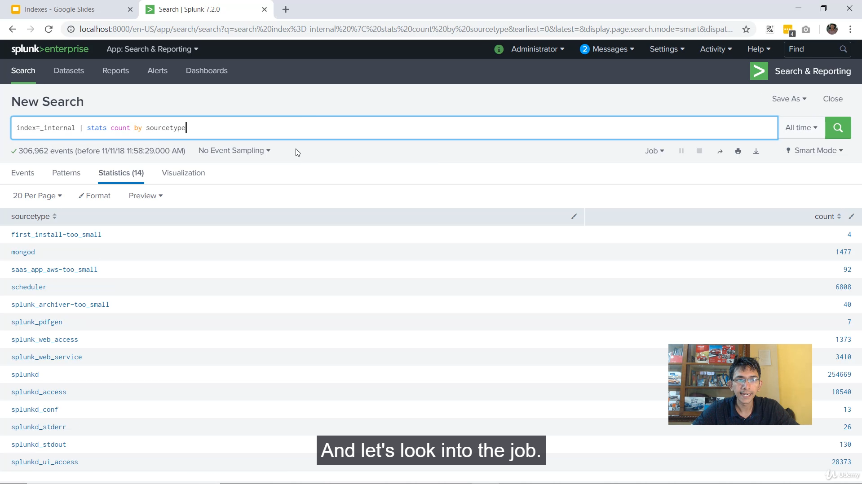

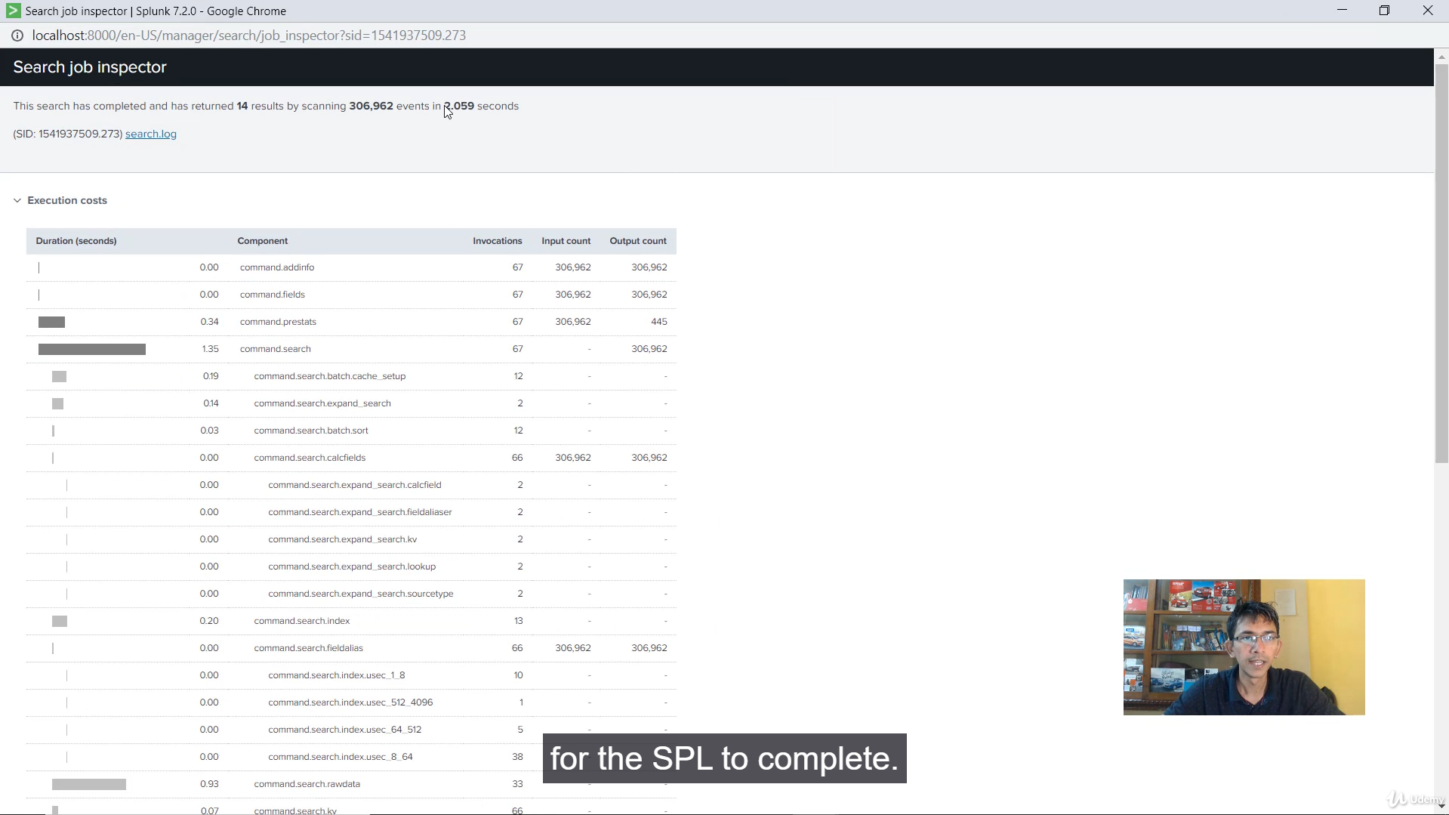

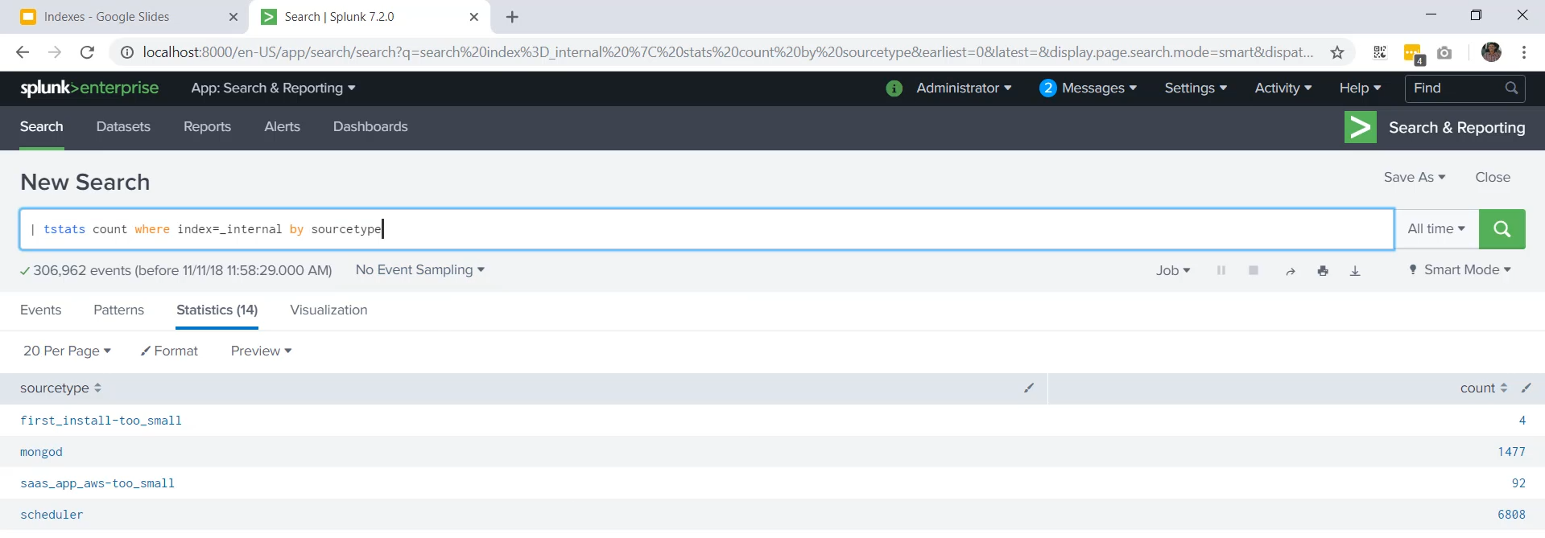

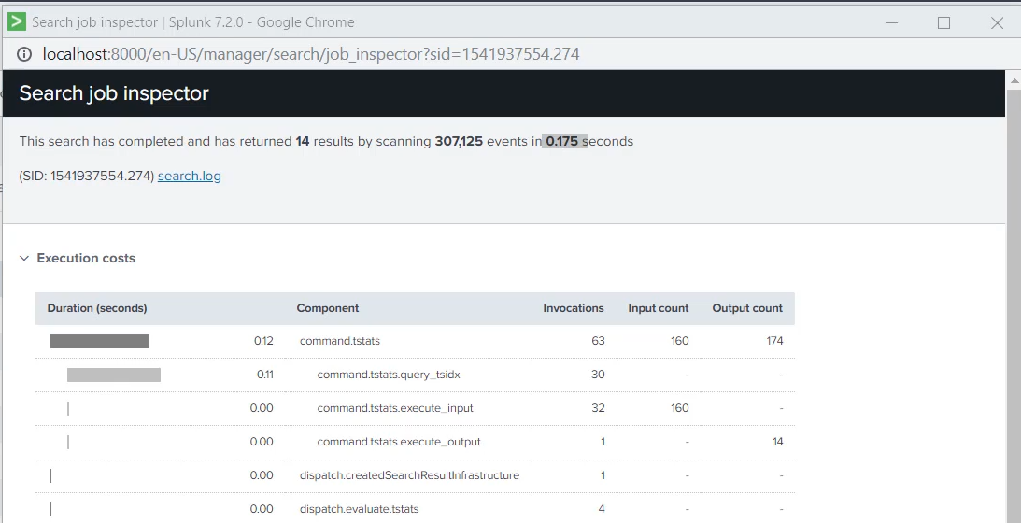

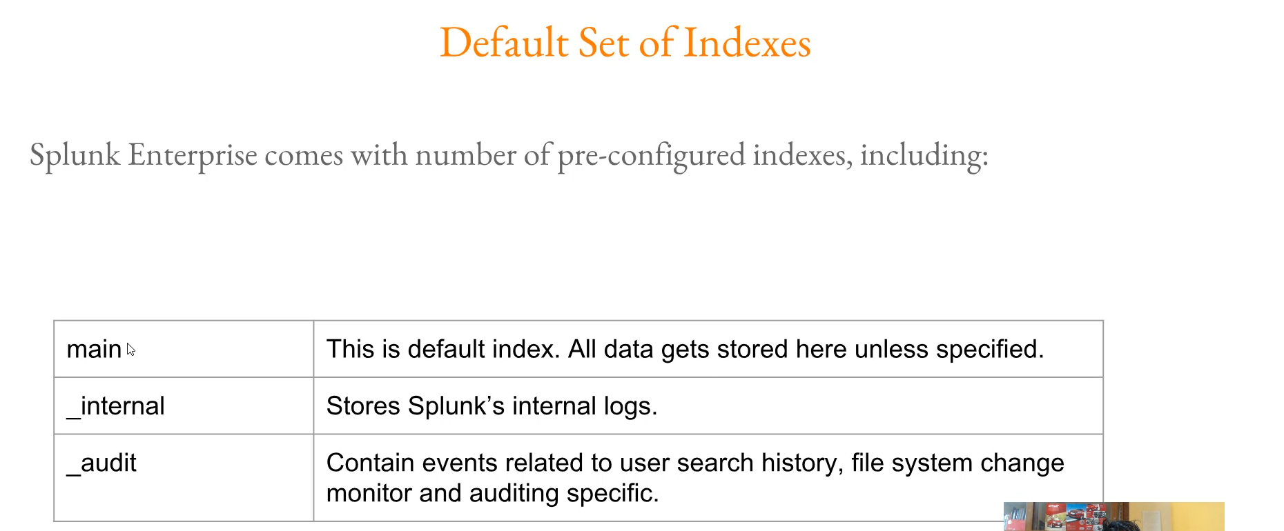

**Splunk Indexes Summary**

**1. Definition and Core Function**

* **Index as a Repository:** In simple terms, a Splunk **index** is a repository for Splunk data.
* **Data Storage:** Whatever data you input into Splunk is transformed into **events** and subsequently stored in an index.
* **Transformations:** Splunk transforms incoming data into events in the **parsing pipeline** (including normalization and regex transformation).

**2. Index File Structure (After Indexing)**

Once Splunk indexes your data, it creates several files that fall into two main categories:

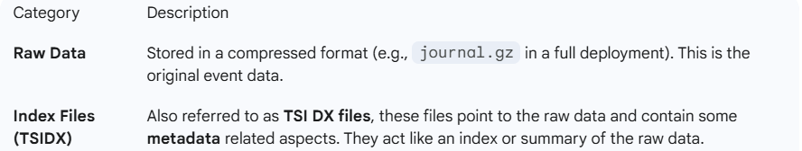

**3. Data Flow Pipeline**

The data flow within Splunk follows a specific path before reaching the index:

1. **Input:** Data enters Splunk from various sources (monitored inputs, UDP, TCP).
2. **Parsing Queue** $\rightarrow$ **Parsing Pipeline:** Data is converted into events (normalization/regex).
3. **Index Queue** $\rightarrow$ **Index Pipeline.**
4. **Storage:** The data is finally stored in the raw data directory and the index files (TSIDX).

**4. Index Creation and Location**

* **Indexes in Settings:** You can view and manage indexes in Splunk by going to **Settings** $\rightarrow$ **Indexes**.
* **Index as a Container:** An index should be considered a **container** where your data is put.
* **Physical Location (Default):** On the filesystem, indexes are generally stored under: OPT/Splunk/var/lib/<index_name>.
  + Creating a new index (e.g., "**KP Labs**") creates a new directory named after the index (e.g., KP Labs).
  + Inside the index directory, the main directory of interest is **DB**.
  + When data is added, a directory like hot_event_0 is created inside DB.

**5. Raw Data vs. TSIDX (The Speed Difference)**

* **Raw Data Content:** Contains the data itself (the actual events). Splunk will generally compress the raw data (e.g., using GZ compression).
* **TSIDX File Content (The Index):** It is like the index of a textbook; it contains a **summary** of what is present in the raw data (e.g., host, source, source type information).
  + **Not everything** is stored in the TSIDX file, similar to how not every word is in a book's index.
  + **Speed Advantage:** Scanning directly through the **TSIDX file** is significantly **faster** than scanning the raw data directly (which requires uncompressing and searching the events).
* **Command Comparison (Demonstration):**
  + stats count by source type: Looks into the **raw data**. (e.g., Took **2.059 seconds**)
    - index="_internal" | stats count by sourcetype
  + tstats count by source type: Looks only into the **TSIDX file**. (e.g., Took **0.175 seconds**)
    - | tstats count where index=_internal by sourcetype

**6. Pre-Configured Indexes (Default Indexes)**

Splunk Enterprise comes with three pre-configured indexes:

1. **Main Index:** The **default index**. All data will be stored here unless you specify a different index.
2. **Internal Index (_internal):** Used for storing **Splunk's internal logs** (performance, activity, etc.).
3. **Audit Index (_audit):** Contains events related to:
   * User search history.
   * File system change monitoring.
   * Auditing-specific information.

===================================================================================

1. **Bucket Lifecycle:**

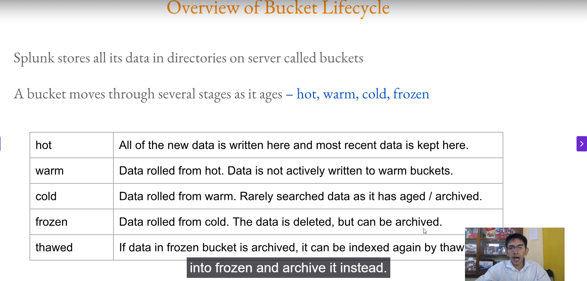

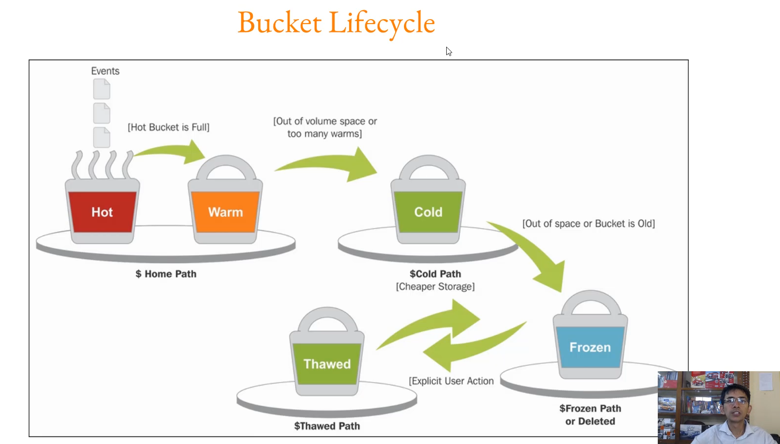

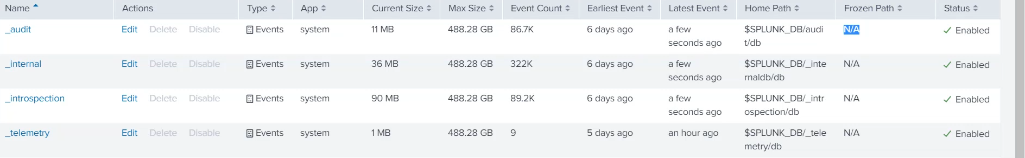

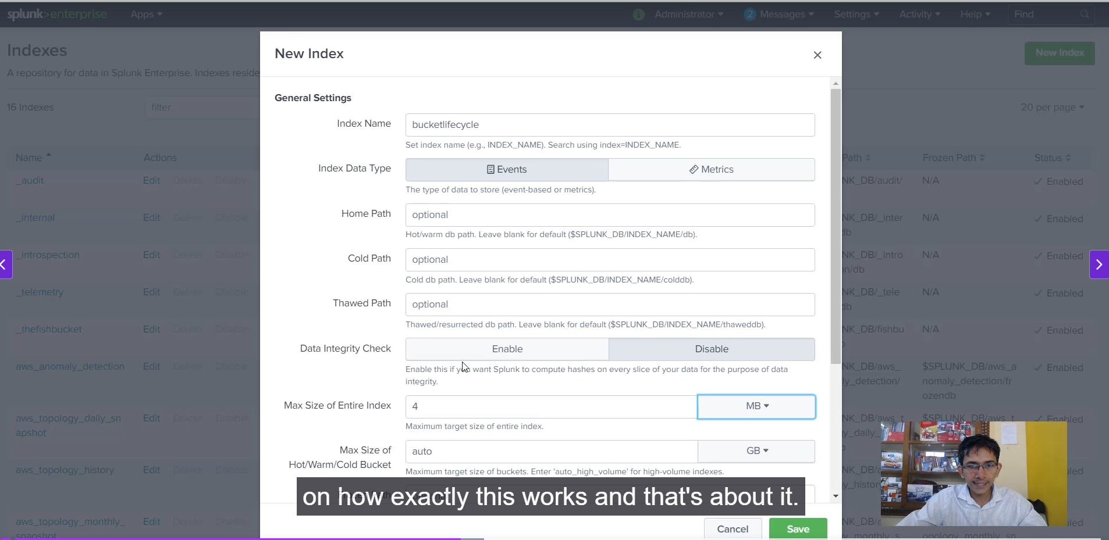

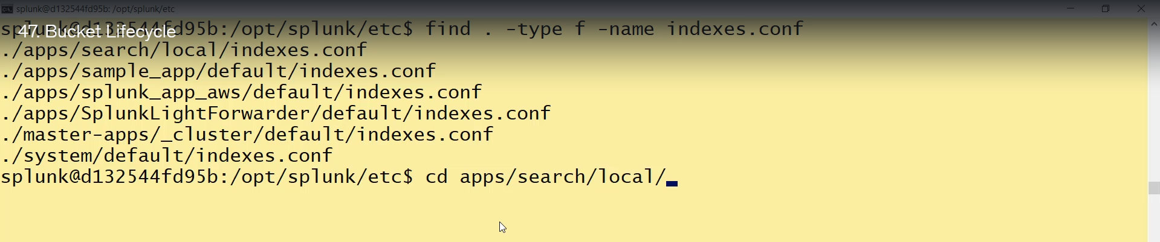

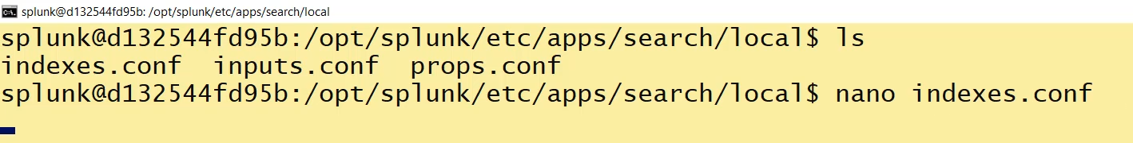

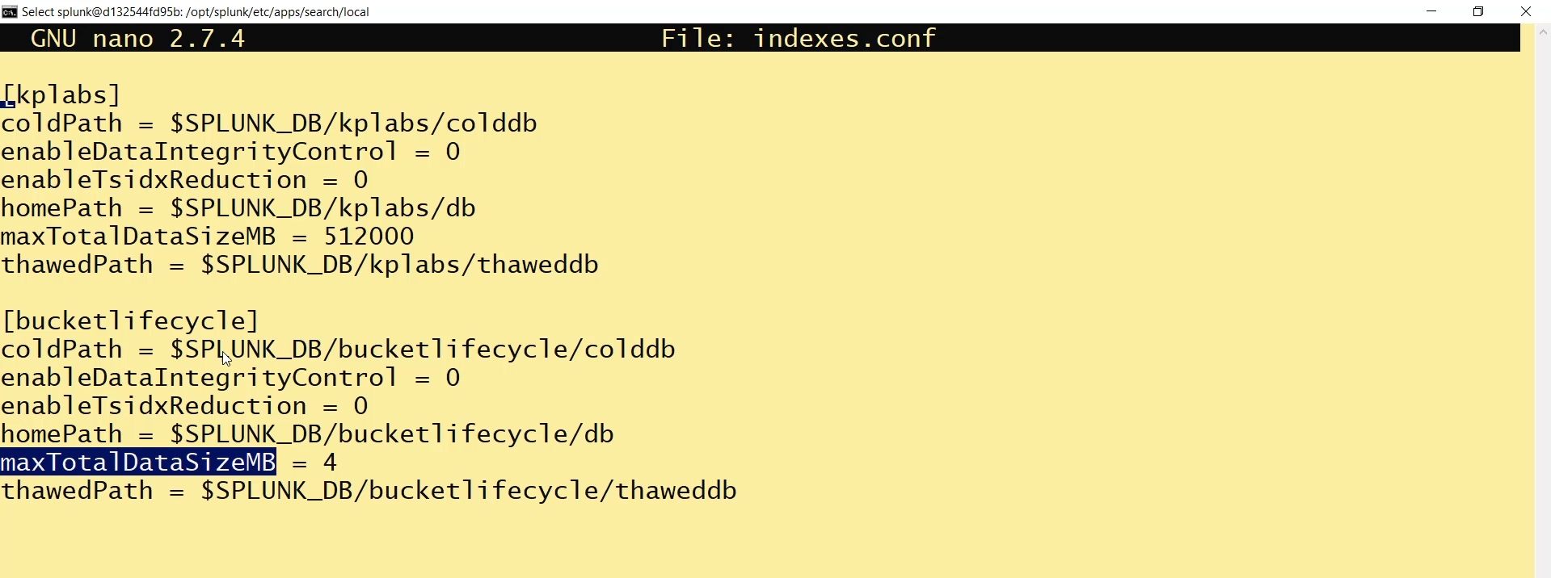

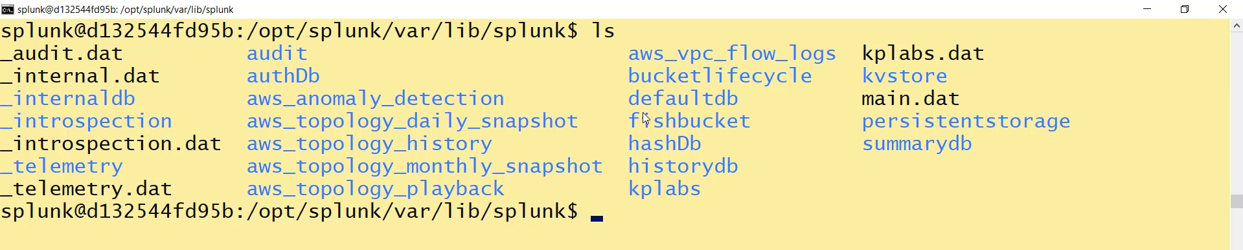

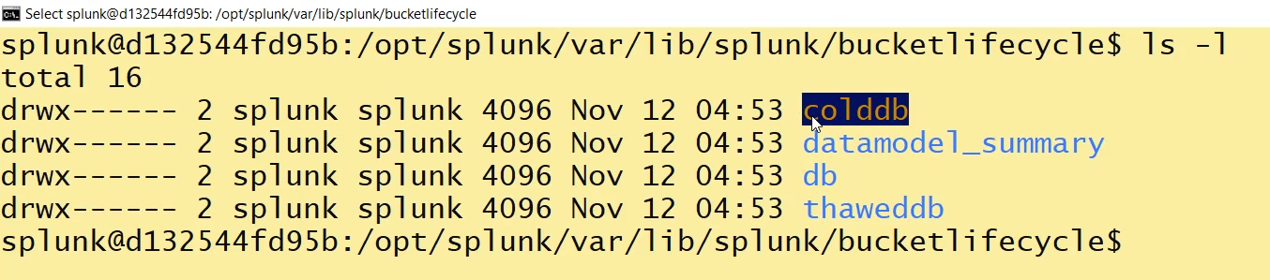



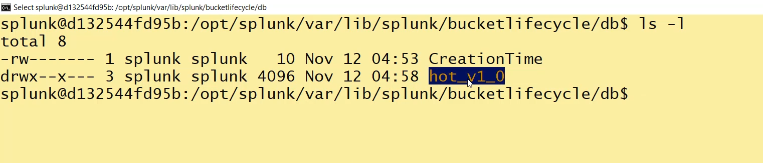

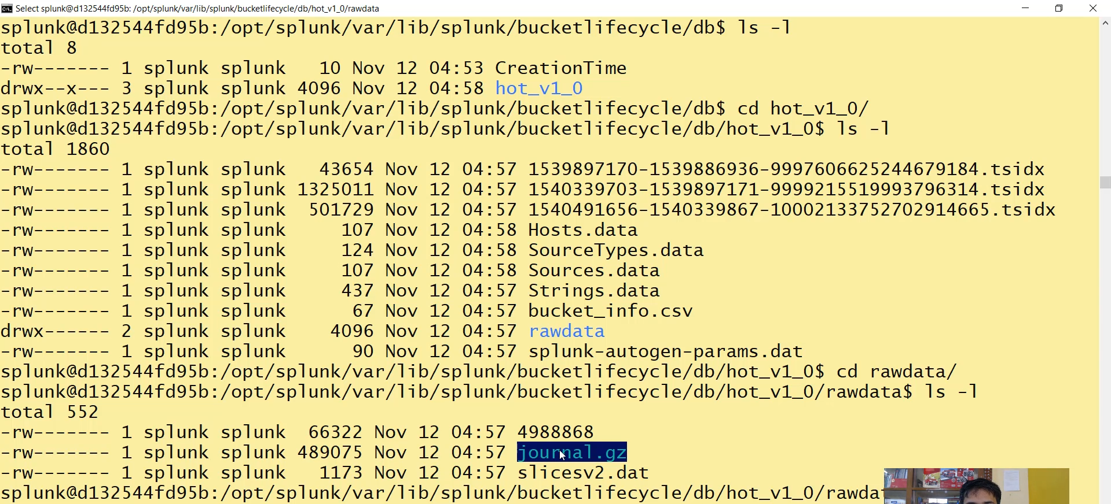

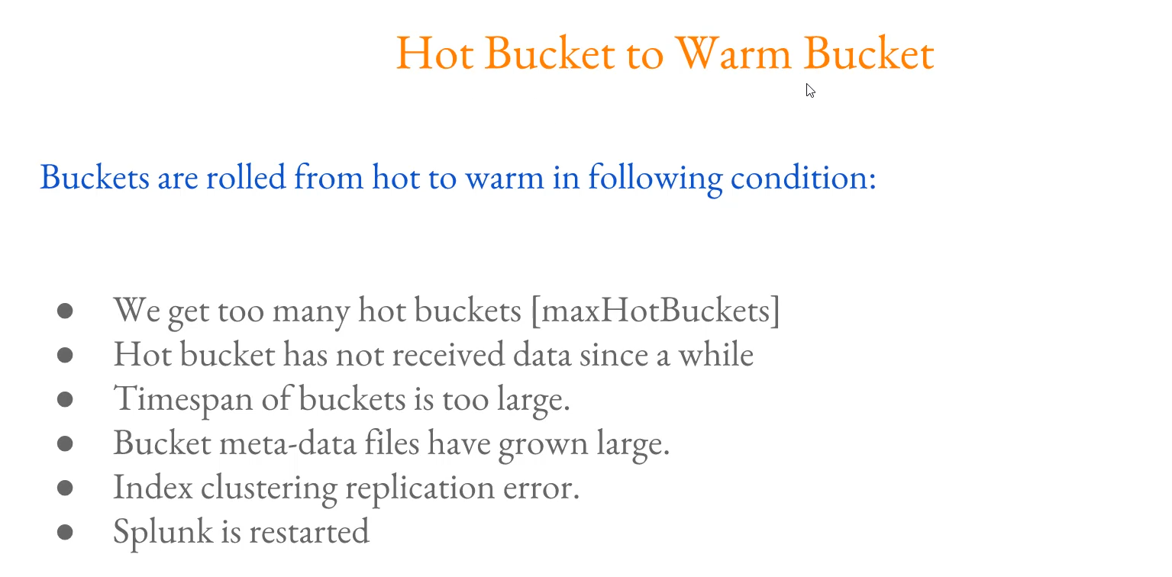

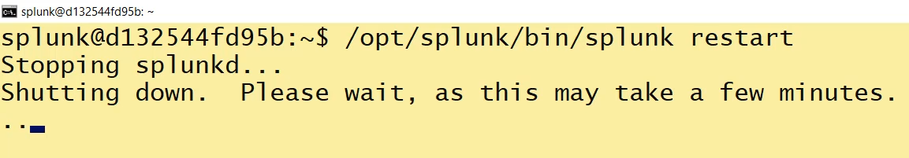

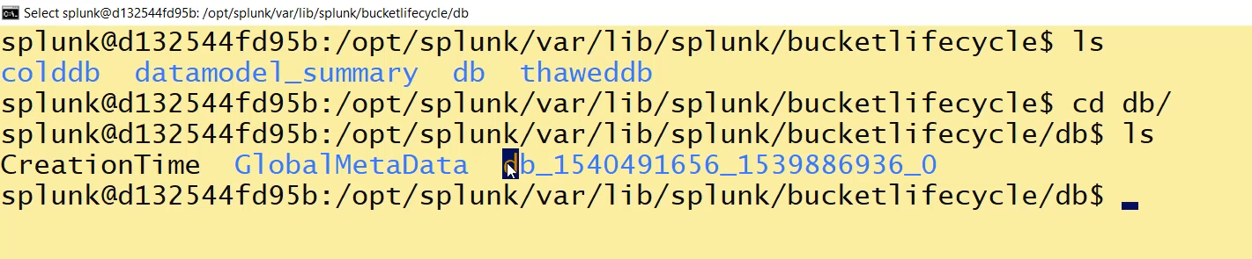

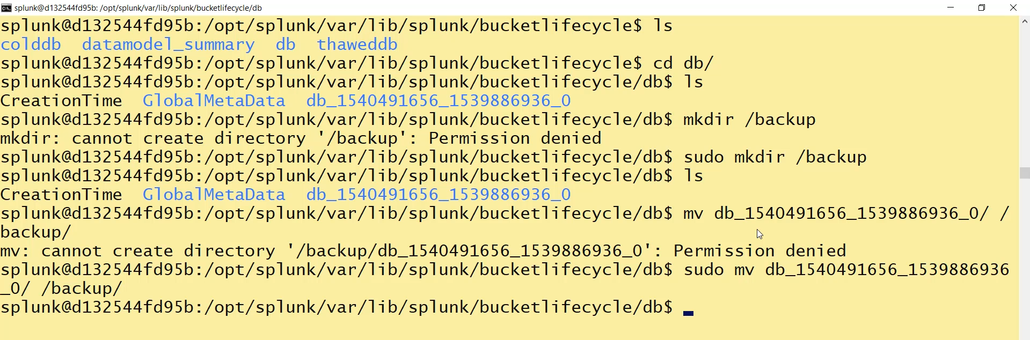

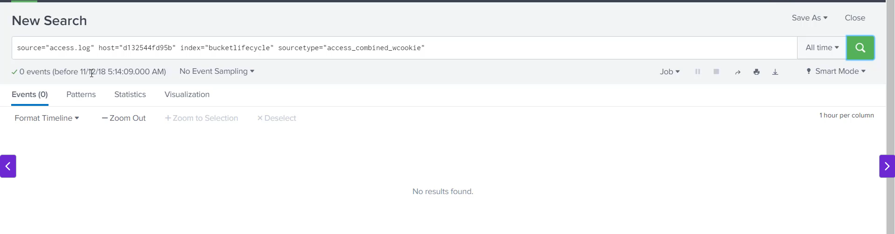

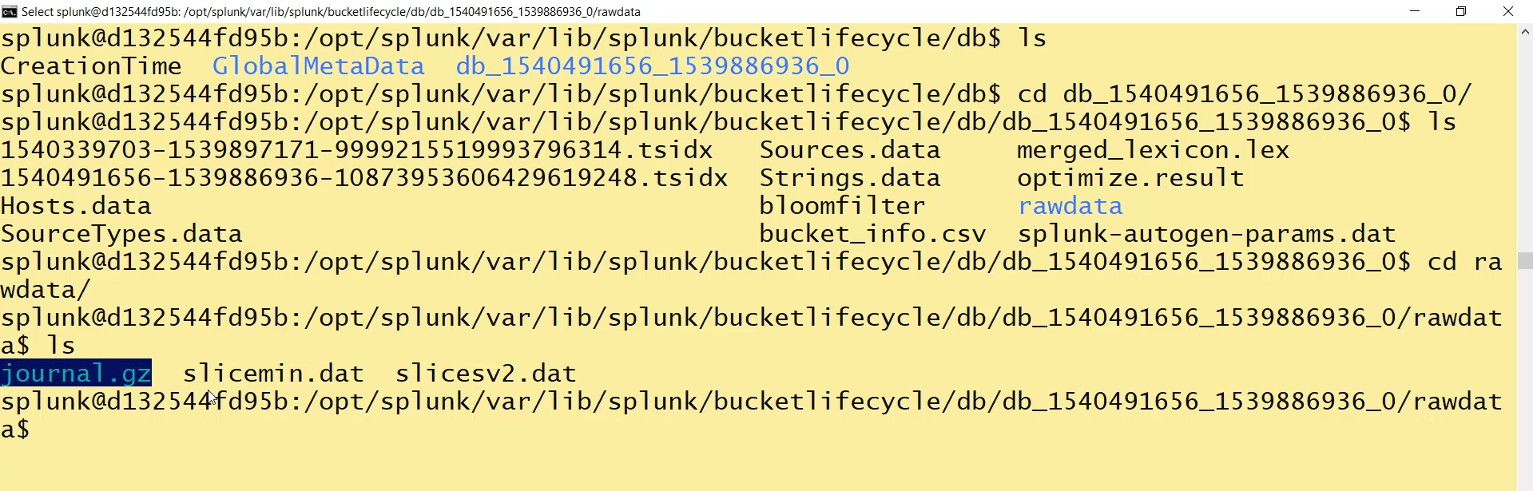

**Splunk Bucket Life Cycle Summary**

**1. Introduction to Buckets**

* **Definition:** Splunk stores all its data in directories, which are technically referred to as **buckets**.
* **Purpose of Aging:** A bucket moves through several stages as it **ages**. This is done because:
  + Analysts typically search recent data (e.g., last 3-7 days) frequently.
  + Older data is searched less frequently.
  + To maintain performance, frequently searched data (Hot/Warm) is stored on a **faster disk**, while older data (Cold/Frozen) can be moved to **less expensive/slower storage**.

**2. The Five Bucket Stages**

Buckets primarily move through five stages based on the age of the data and configured policies:

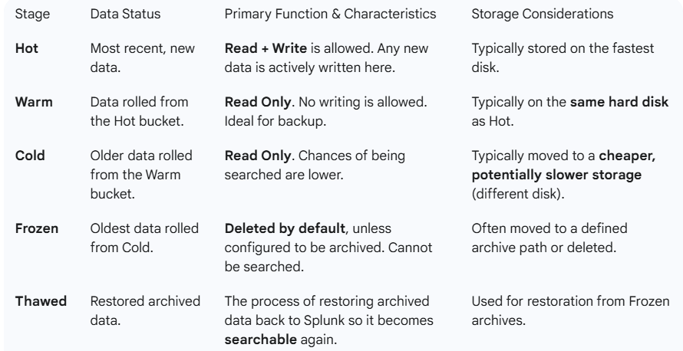

**3. Hot to Warm Roll Conditions**

Data is rolled from the **Hot bucket** to the **Warm bucket** when one of the following conditions is met:

1. **Too many Hot Buckets:** Defined by the max_hot_buckets parameter in indexes.conf.
2. **No New Data:** The Hot bucket has not received data for a specified period.
3. **Time Span too Large:** The time span covered by the bucket is excessive.
4. **Metadata File Size:** Bucket metadata files have grown too large.
5. **Clustering Error:** Index clustering or replication errors occur.
6. **Splunk Restarted:** Splunk is manually or automatically restarted (demonstrated in the video).

**4. Physical Location and Configuration**

* **GUI Configuration:** The index settings show: Max Size, Events Count, path, and **Frozen Path** (if not specified, data is deleted).
* **CLI Location:** Configuration settings are found in the indexes.conf file (e.g., in OPT/Splunk/etc/apps/search/local/indexes.conf).
* **Key Directories:**
  + **DB directory:** Where **Hot and Warm** buckets are stored (e.g., hot_event_0 changes to db_<timestamp>).
  + **Cold DB directory:** Where cold data will be stored.
* **Data Compression:** Splunk actively compresses the raw data (e.g., into journal.gz) to save disk size, which is why the indexed size is often smaller than the original file size.

**5. Backup and Restore Process**

* **Backup Requirement:** Data inside the **Hot bucket cannot be backed up**. You must roll it to a **Warm bucket** first.
* **Warm Bucket Backup:** Once data is in the Warm bucket (db_<timestamp>), it can be safely copied/moved to a backup location (e.g., AWS S3).
* **Data Unavailability:** If a Warm bucket is moved out of the Splunk directory, the data becomes immediately **unsearchable** until it is moved back.
* **Frozen Data Compliance:** Organizations with compliance requirements (e.g., storing data for 1-5 years) must explicitly tell Splunk **not to delete** frozen data and to **archive it** instead.

===================================================================================

1. **Warm to Cold Bucket Migration:**

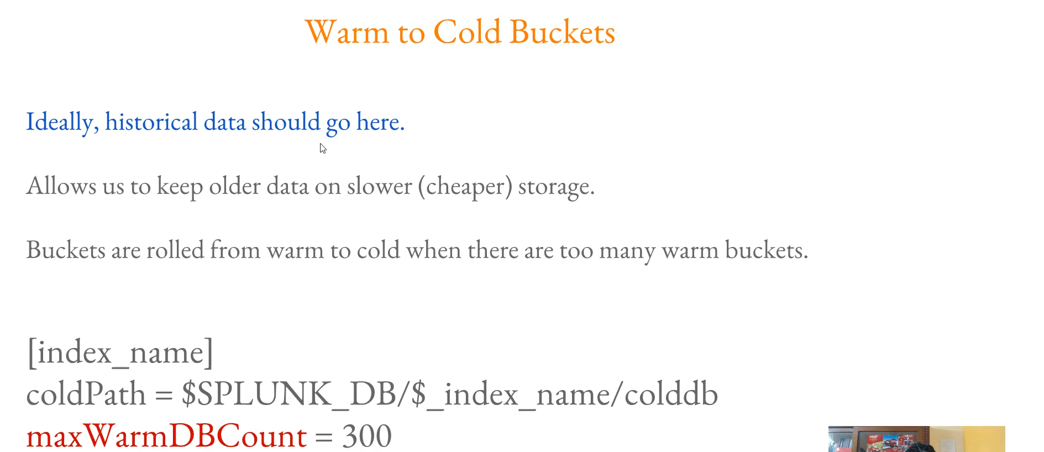

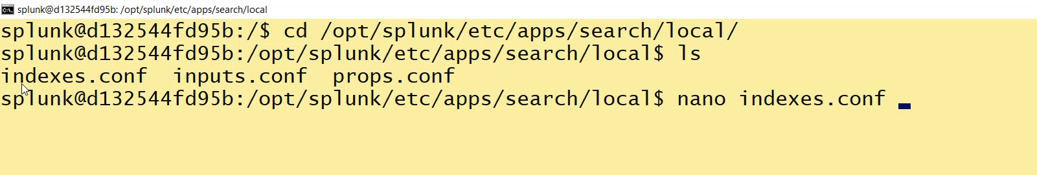

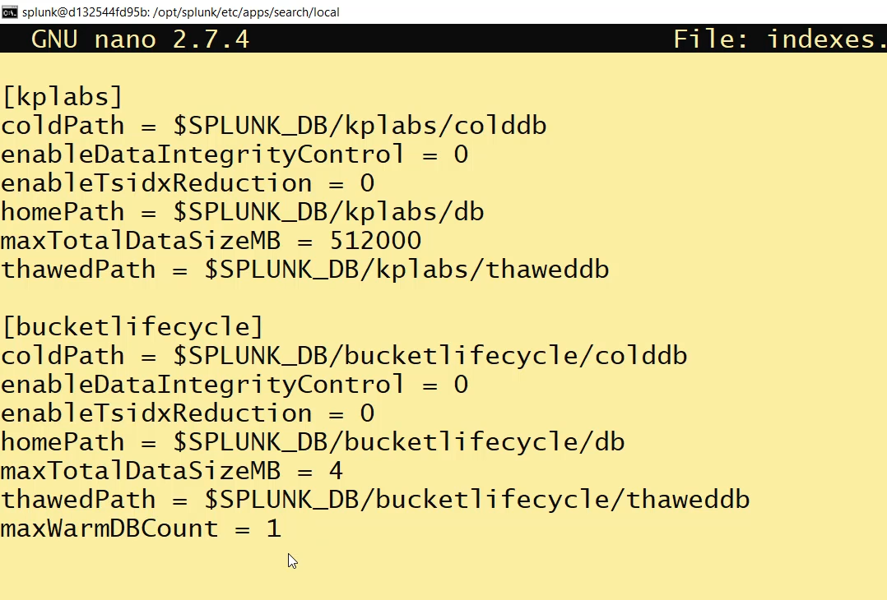

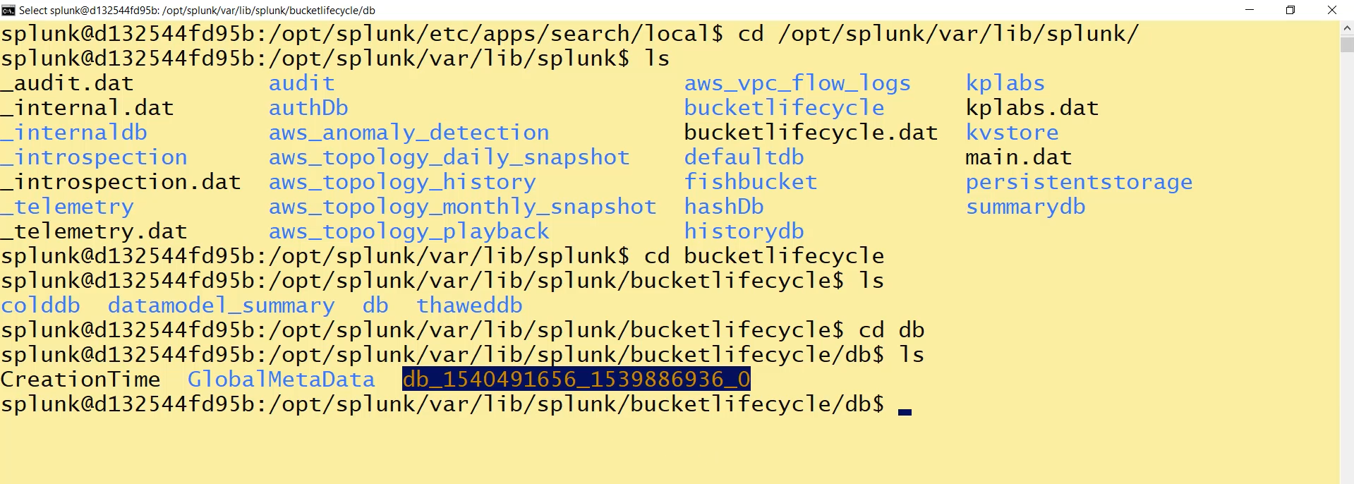

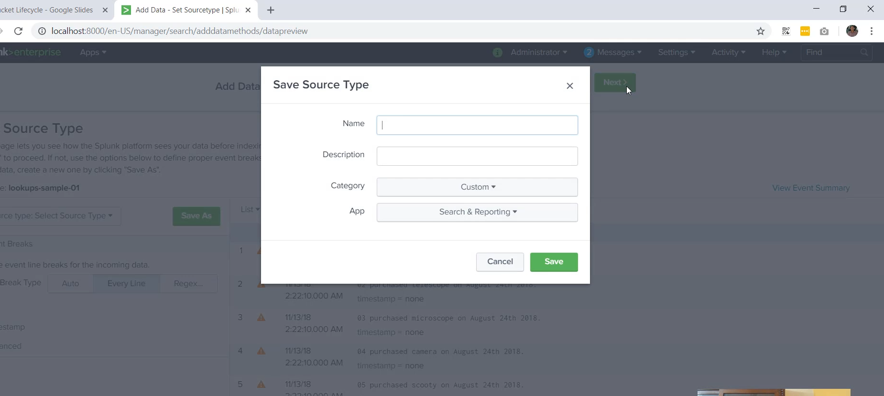





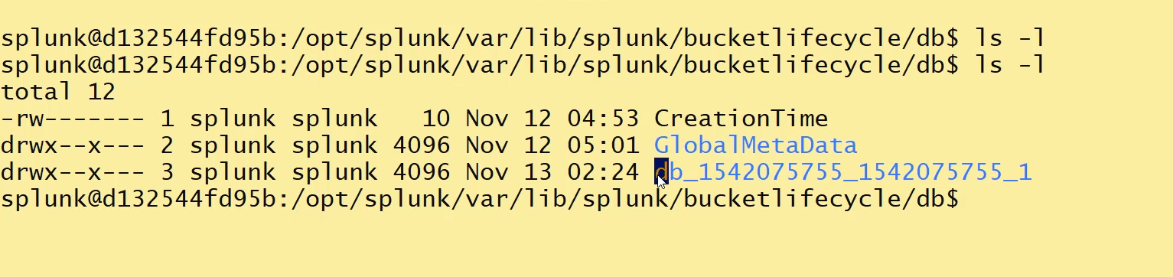

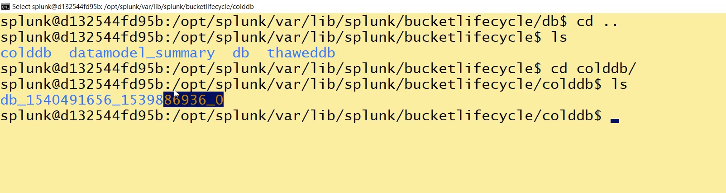

**Warm Bucket to Cold Bucket Transition Summary:**

**1. Ideal Placement of Cold Buckets**

* **Historical Data:** Ideally, historical data (older events) should be stored in the **cold bucket**.
* **Storage Architecture:** Organizations typically implement this architecture to optimize costs and performance:
  + **Hot & Warm Buckets:** Must be on a **fast disk** (high performance) to handle frequent searches.
  + **Cold Bucket:** Can be placed on a **cheaper, slower storage** since this data is searched less often.
* **Performance Warning:** Searching data located in the Cold bucket will have a **performance impact** compared to searching Hot or Warm data.

**2. Roll Condition: Maximum Warm DB Count**

Buckets are rolled from **Warm to Cold** primarily when there are **too many Warm buckets**.

* **Configuration Parameter:** This limit is defined in the indexes.conf file using the configuration key: maxWarmDBCount.
  + **Default Value:** If not configured, Splunk uses its own default rule.
  + **Example Configuration:** Setting maxWarmDBCount = 300 means a maximum of 300 warm buckets can exist. Once this limit is reached, the oldest warm bucket will be moved to cold storage.

**3. Practical Demonstration of Warm to Cold Roll**

The instructor demonstrated this process by setting maxWarmDBCount = 1 for the bucket_lifecycle index:

1. **Initial State:** The index had **one Warm bucket** (rolled from a previous Hot bucket) and was configured for a maximum of 1 Warm bucket.
2. **Adding New Data:** A small text file was uploaded, creating a **new Hot bucket**.
   * State before restart: 1 Warm bucket + 1 Hot bucket.
3. **Restarting Splunk:** Upon restart, two rolling actions occurred because the Warm limit was violated:
   * The existing **Warm bucket** was rolled to the **Cold DB** directory.
   * The existing **Hot bucket** was rolled to become the **new Warm bucket**.
4. **Verification:**
   * Only **one Warm bucket** was left in the main DB directory (opt/Splunk/var/lib/Splunk/bucket_lifecycle/db).
   * The previously Warm bucket was successfully migrated to the **cold db** directory (opt/Splunk/var/lib/Splunk/bucket_lifecycle/colddb).

**4. Storage Path Considerations (Best Practice)**

* **Current Setup Issue:** The demonstration showed the cold db directory being created within the main Splunk volume, which is the fast disk.
* **Best Practice:** In a real-world scenario, you should configure the coldPath setting in indexes.conf to point to a **separate, cheaper disk** (slower storage) to optimize storage costs.
  + The main disk should only contain the high-performance **Hot and Warm** buckets.

===================================================================================

1. **Archiving Data to Frozen path:**

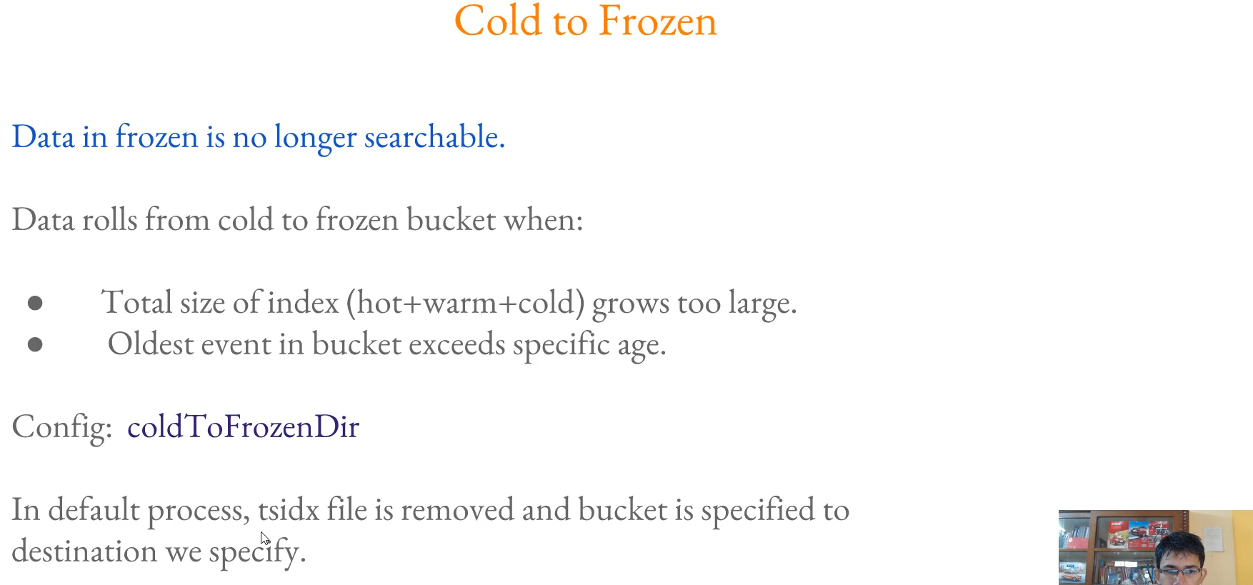

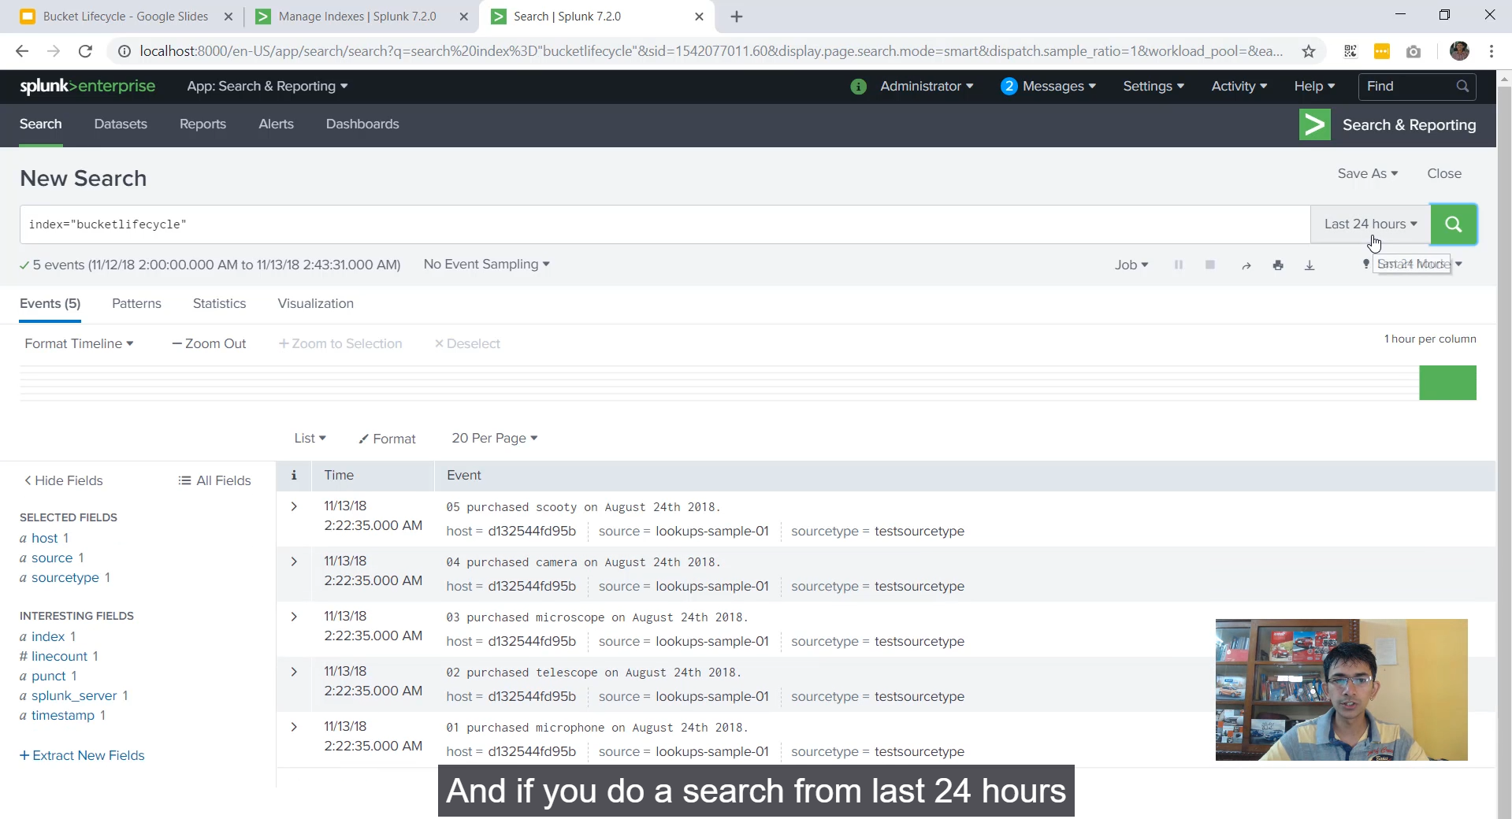

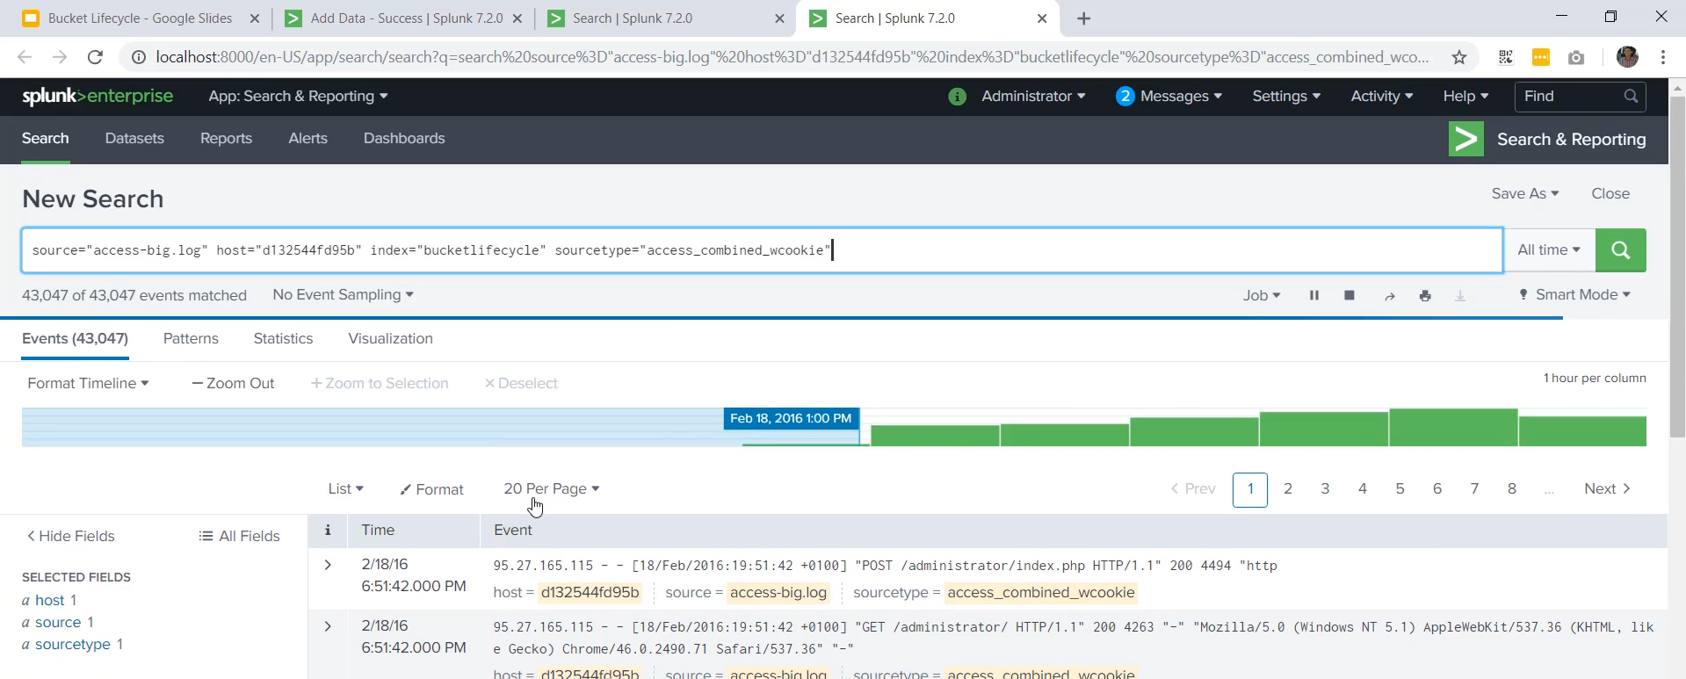

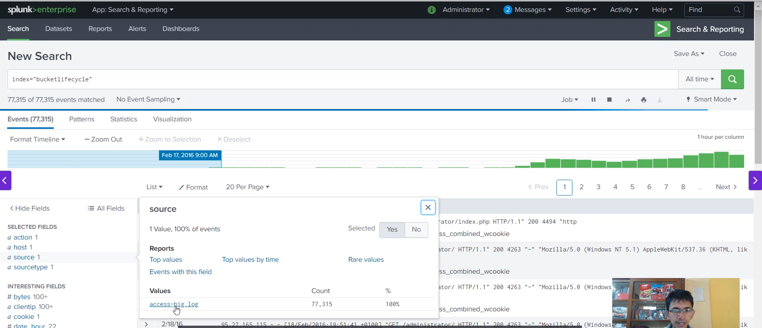

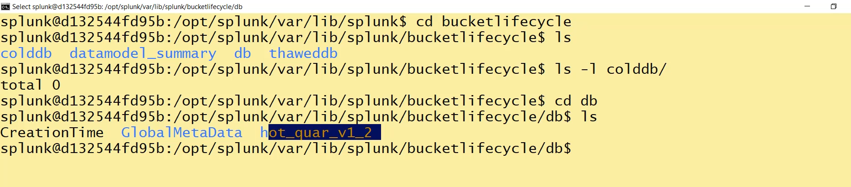

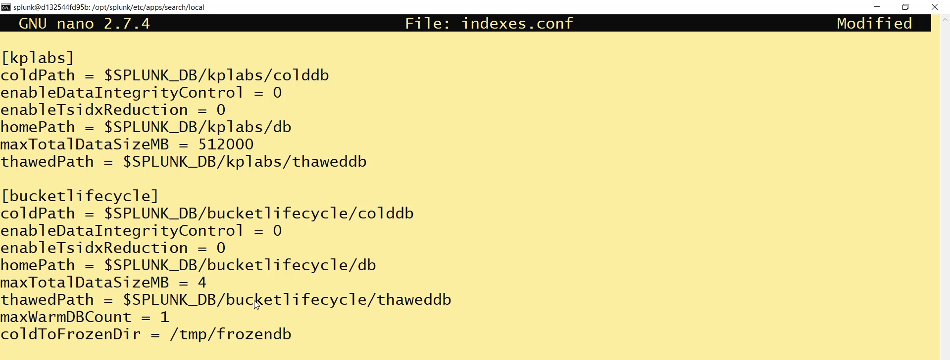

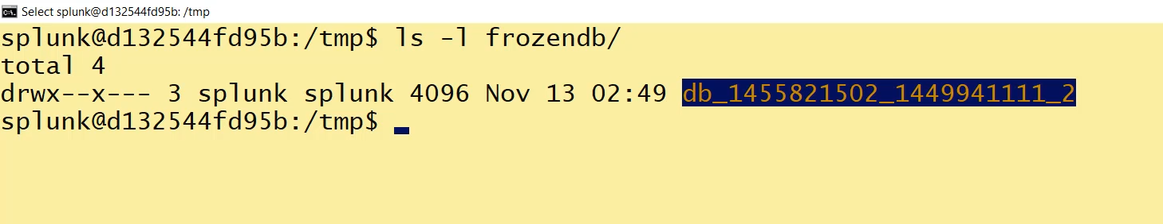

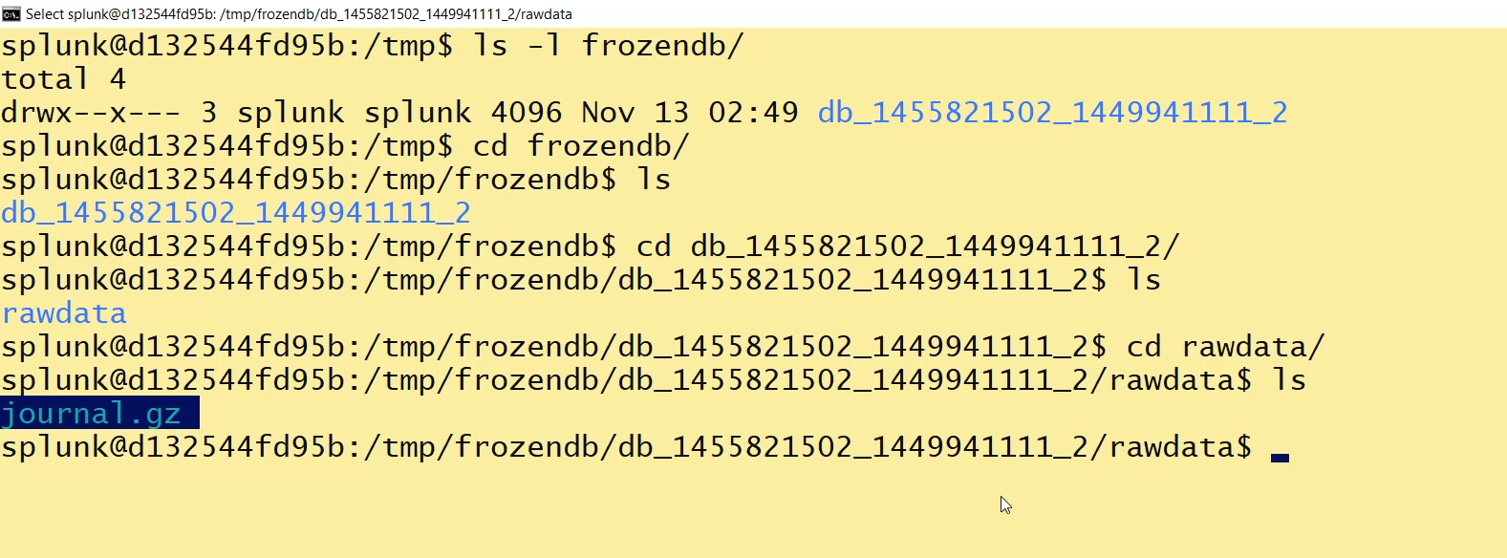

Hello! Here is the summary for the final video in the Splunk bucket life cycle series, covering the move from Cold to Frozen.

**🥶 Cold Bucket to Frozen Bucket Summary**

**1. Frozen Bucket Characteristics**

* **Searchability:** Data in the Frozen bucket is **no longer searchable** within Splunk.
* **Default Action:** By default, Splunk **deletes** the data when it moves to the Frozen stage, unless explicitly instructed not to.
* **TSIDX Removal:** In the default freezing process, the **TSIDX file is removed**. Only the raw data (in a compressed format, e.g., journal.gz) is retained or archived.
  + **Verification:** The demonstration confirmed the absence of the TSIDX file in the frozen_db directory, leaving only rawdata/journal.gz.

**2. Conditions for Cold to Frozen Roll**

Data rolls from the Cold bucket to the Frozen bucket when one of the following factors is met:

1. **Index Size Exceeded:** The **total size of the index** (Hot + Warm + Cold data combined) grows too large, surpassing the configured maxDataSize limit.
2. **Age Limit Exceeded:** The **oldest event** in the bucket exceeds a specific age limit defined in the configuration.

**3. Archiving Frozen Data (Best Practice)**

* **Configuration Parameter:** To prevent deletion and enable archiving, you must configure the indexes.conf file with the parameter:
  + coldToFrozenDir = <path_to_archive_directory>
* **Compliance Requirement:** It is highly recommended to **archive** data instead of deleting it, especially for security and compliance reasons.
  + Many compliance regulations require data retention for periods like one year or more.
  + If a security breach is discovered months after the fact, the archived logs are critical for investigation, making data deletion risky.

**4. Practical Demonstration (Index Size Exceeded)**

The instructor demonstrated the **index size exceeded** condition:

1. **Initial State:** The index (bucket_lifecycle) had a current size of **3 MB** and a configured maximum size of **4 MB**.
2. **Upload Action:** A large file (**28 MB**) was uploaded, causing the total size to significantly exceed the 4 MB limit.
3. **Splunk Behavior:** Splunk immediately rolled and deleted the **earlier data** (the original events from the lookup file) by moving them to the Frozen stage. Since no coldToFrozenDir was initially configured, the older data was deleted and was no longer searchable.
4. **Implementing Archiving:**
   * The coldToFrozenDir parameter was set to a new directory (e.g., /temp/frozen_db) in indexes.conf.
   * Splunk was restarted.
   * Subsequent data that rolled to the Frozen stage was correctly moved to the /temp/frozen_db directory instead of being deleted.

===================================================================================

1. **Archiving Data to Frozen path:**

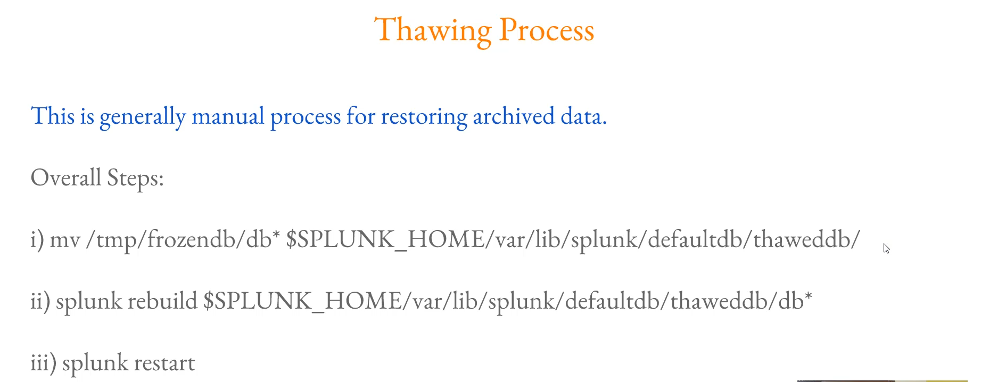

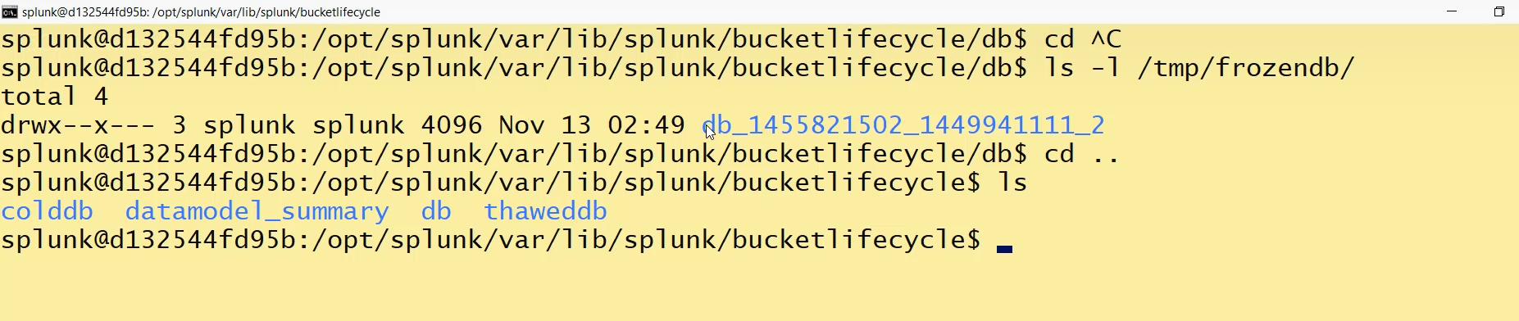

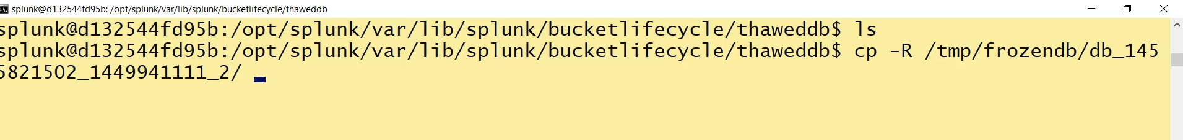

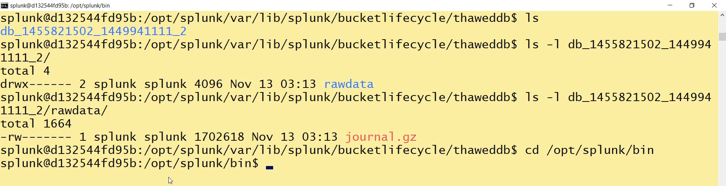

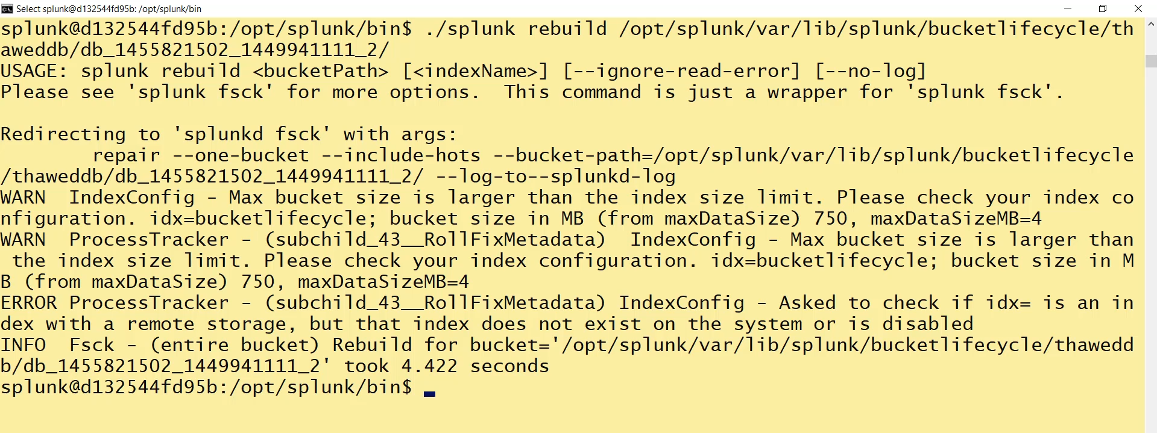

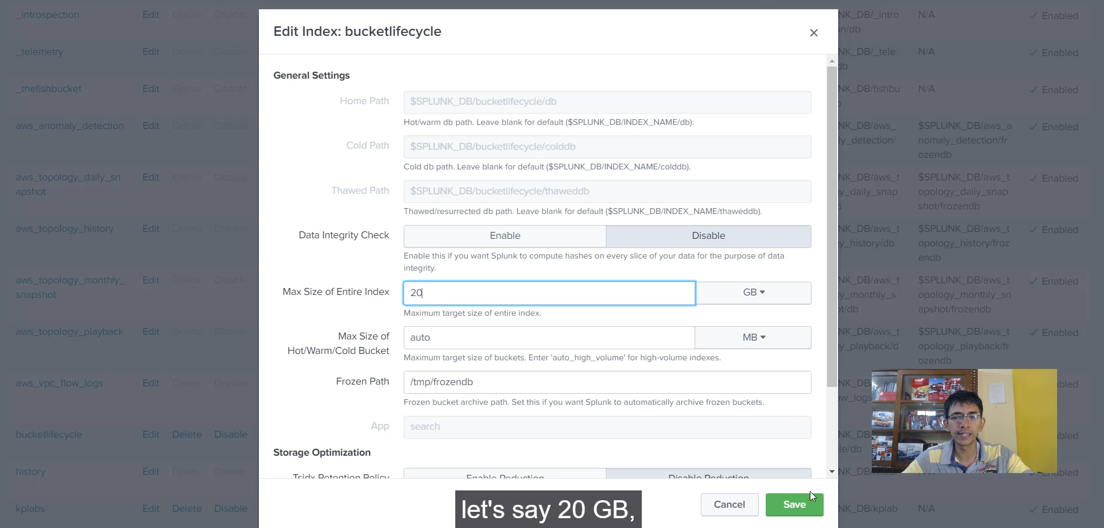

**Thawing (Restoration) Process Summary**

**1. Introduction to Thawing**

* **Definition:** Thawing is the **manual process** of restoring archived data from the **Frozen DB** back into Splunk so it becomes searchable.
* **Frozen Data Status:** Data in the Frozen DB only contains the raw, compressed format (e.g., journal.gz). It is missing the necessary index metadata files (TSIDX).

**2. The Three Steps of Thawing**

The restoration process requires three key steps:

1. **Move/Copy Data to $SPLUNK_HOME/var/lib/splunk/<index>/thaweddb:**
   * The archived bucket directory must be moved/copied from the coldToFrozenDir (Frozen DB) to the specific $SPLUNK_HOME/var/lib/splunk/<index>/**thaweddb** directory.
2. **Run the splunk rebuild Command:**
   * This command is run from the $SPLUNK_HOME/bin directory.
   * It rebuilds the missing metadata (TSIDX files) for the bucket(s) located in the thaweddb path, effectively re-indexing the raw data.
   * **Syntax:** splunk rebuild <path_to_thaweddb_bucket> (e.g., splunk rebuild OPT/Splunk/var/lib/Splunk/bucket_lifecycle/thaweddb/db_...)
3. **Restart Splunk:**
   * A full Splunk restart is required for the system to recognize and fully integrate the newly rebuilt bucket(s) into the index.

**3. Index Size Consideration (Critical Point)**

A crucial check must be performed before rebuilding archived data:

* **Problem:** The splunk rebuild command might fail (as demonstrated) or, if successful, the new data will immediately roll to frozen again if the index's maximum size limit (maxTotalDataSizeMB) is smaller than the size of the data being restored.
* **Solution/Best Practice:** Before attempting to thaw/rebuild data, you must:
  + **Increase the Index Size:** Edit the index configuration (via GUI or indexes.conf) to ensure the index size is **large enough** to accommodate both the currently indexed data *and* the archived data being restored.
  + **Example:** If your current index is 10 GB and you restore 2 years of archived data (20 GB), you must increase the max size by at least 20 GB.

**4. Conclusion of the Bucket Life Cycle**

* The video concludes the detailed exploration of the Splunk bucket life cycle (**Hot** $\rightarrow$ **Warm** $\rightarrow$ **Cold** $\rightarrow$ **Frozen** $\rightarrow$ **Thawed**).
* The emphasis was placed on understanding the concepts and practical applications of data aging and management in Splunk.

===================================================================================

1. **Splunk Workflow Actions:**

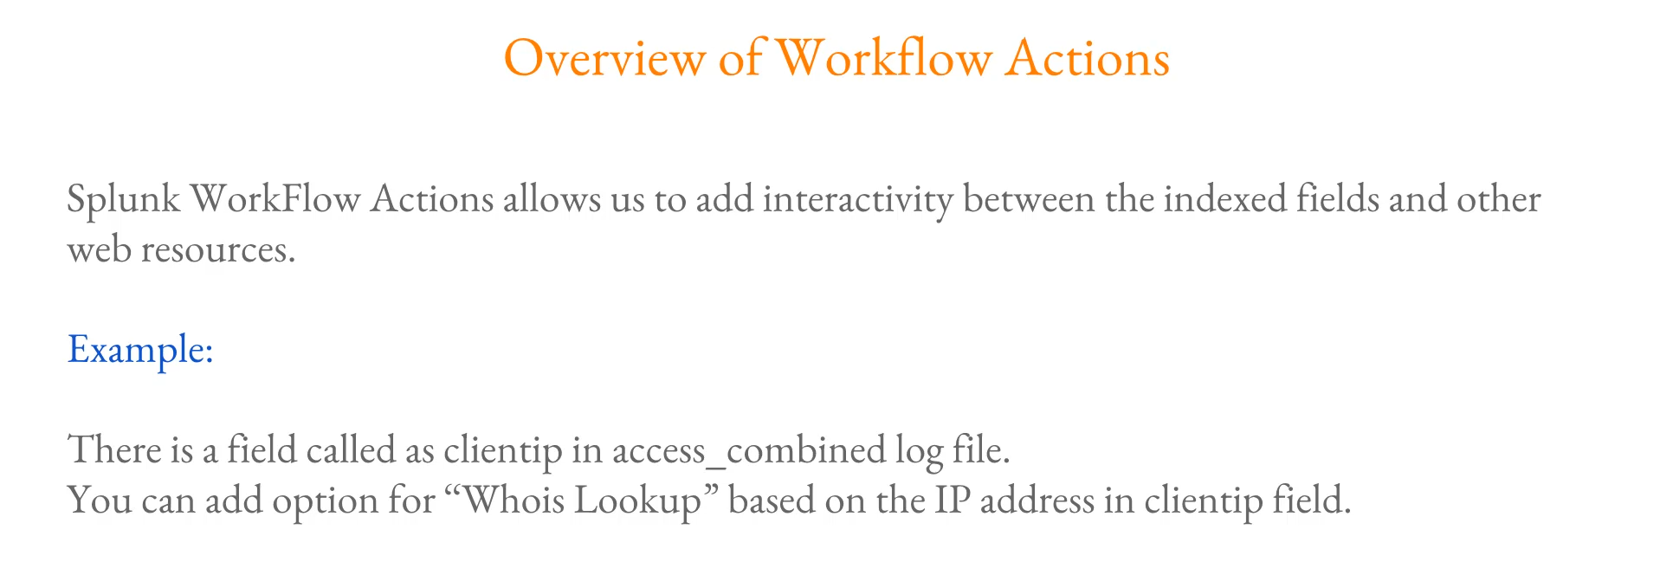

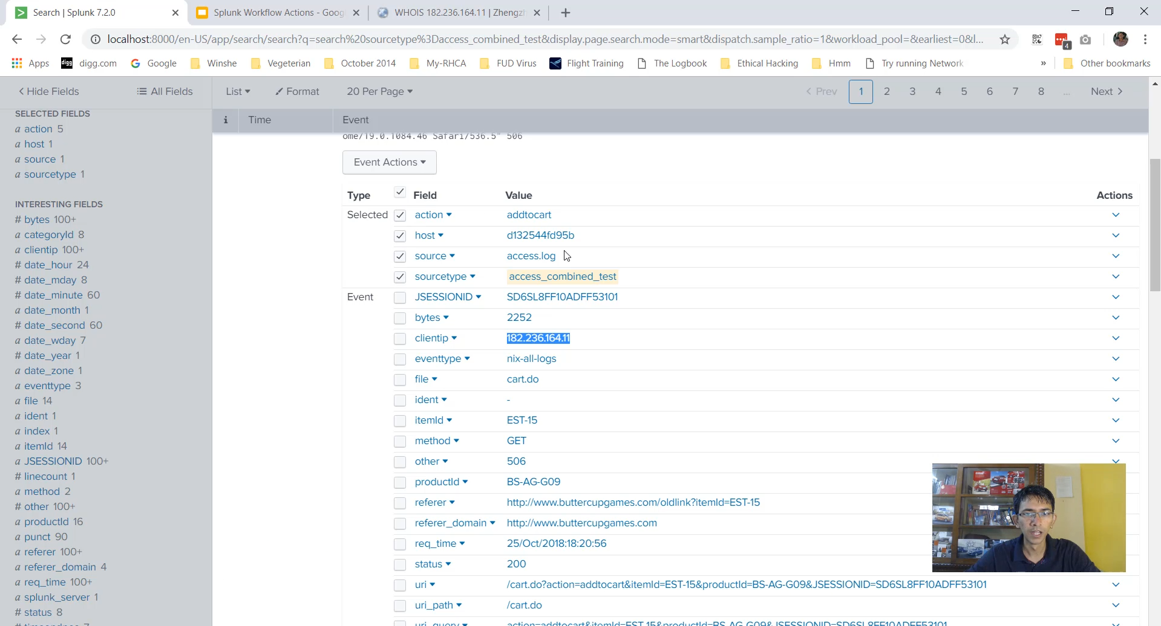

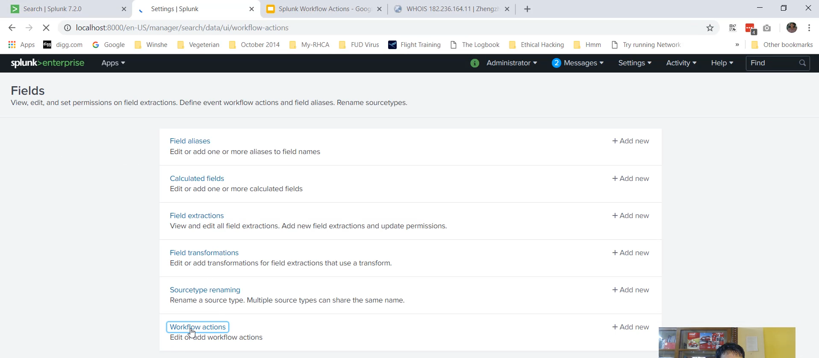

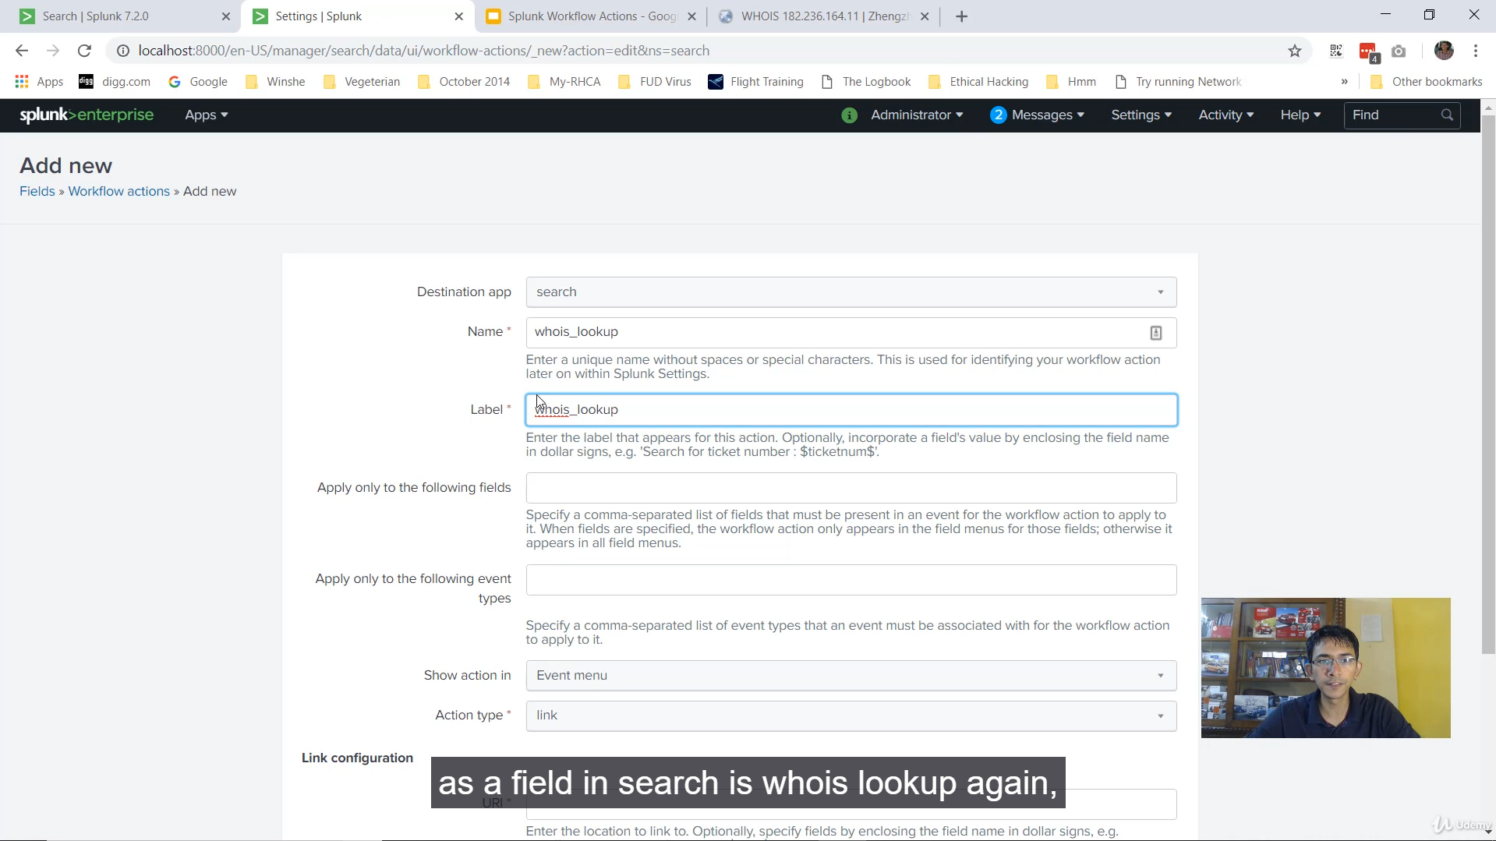

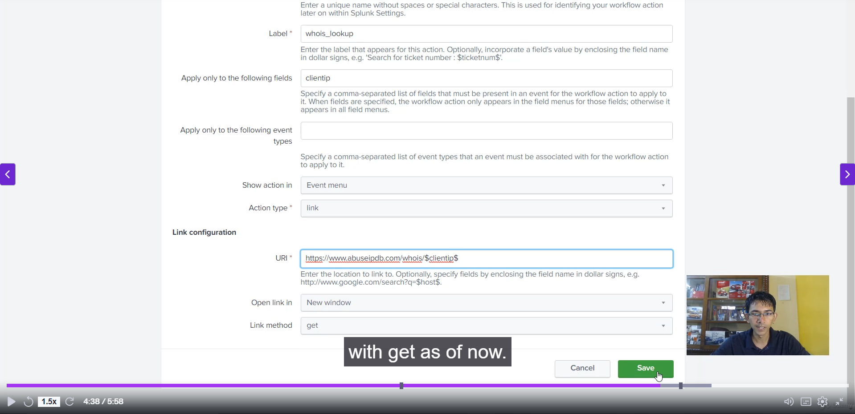

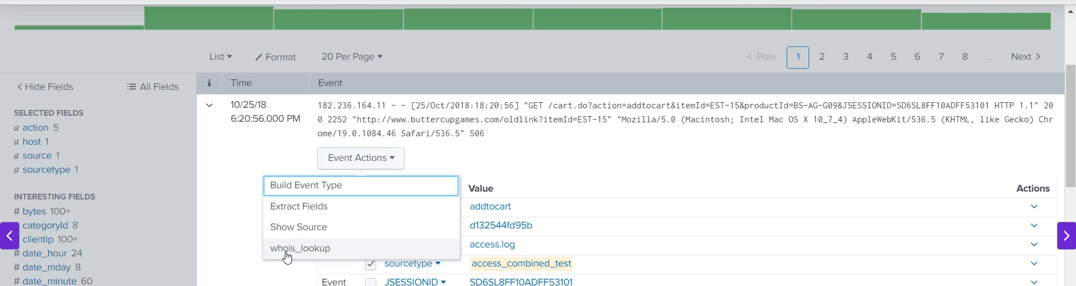

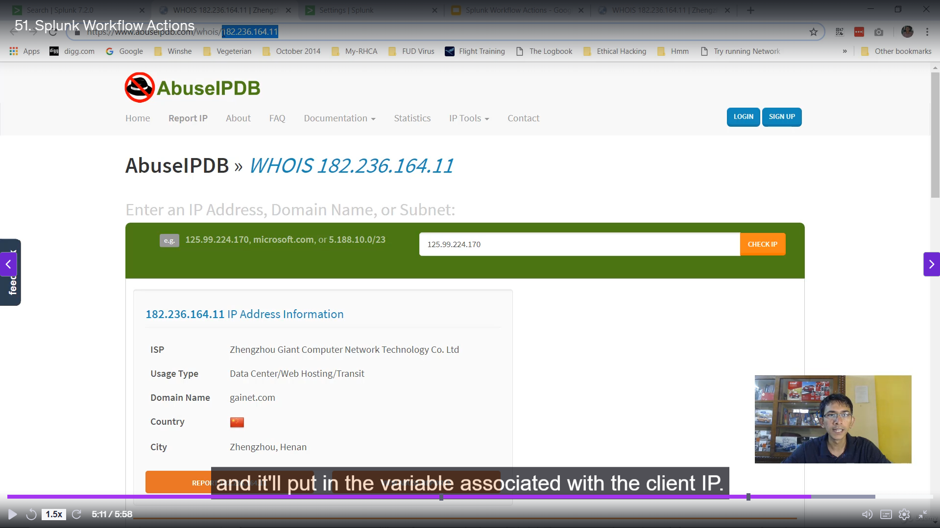

**Splunk Workflow Actions Summary**

**1. Core Concept and Purpose**

* **Interactivity:** Splunk Workflow Actions add **interactivity** between an indexed field (like an IP address) and **external web resources** (like a threat intelligence website).
* **Automation:** They automate the process of querying external sources, saving the analyst from manually copying a field value, opening a new tab, and pasting the value into a search engine or specific lookup tool.
* **Context:** This feature is highly valuable during the **analyzing phase**, especially in **security analysis** (SIEM use cases) for quickly enriching security events.

**2. Example Use Case (Client IP Lookup)**

* **Goal:** Quickly check if a specific **Client IP** address found in logs is blacklisted or known for malicious activity (e.g., spamming).
* **Manual Steps (Eliminated):**
  1. Copy the IP address value.
  2. Open a web browser (e.g., Google or a site like abuseipdb.com).
  3. Paste the IP and search.
* **Workflow Action Steps:** The analyst simply clicks the field and selects the defined action to be redirected instantly.

**3. Configuration Steps**

To create a Workflow Action, navigate to **Settings** $\rightarrow$ **Fields** $\rightarrow$ **Workflow Actions**.

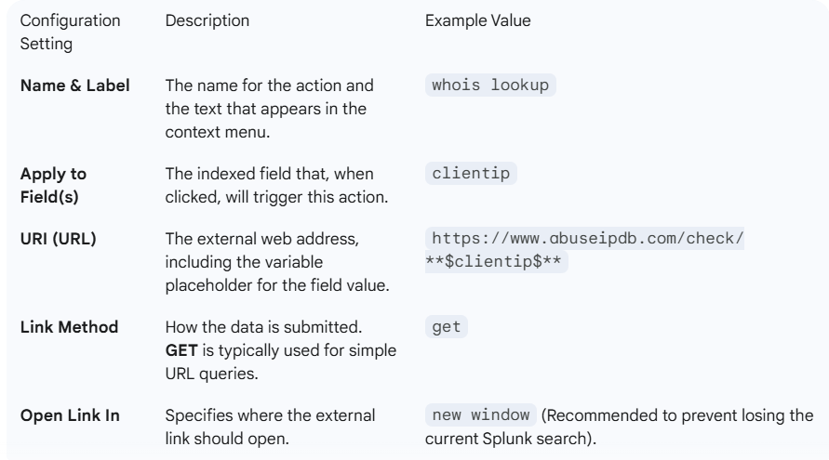

**4. Execution and Output**

1. After creating and saving the action, the Splunk search interface may need to be **refreshed** due to caching.
2. When viewing an event in the Search app, clicking on the **Client IP** field value (or using the **Event Actions** menu) will reveal the new "whois lookup" action.
3. Clicking the action automatically constructs the URL, inserts the IP address, and opens a new window, presenting the analyst with external data (e.g., country, city, ISP, abuse reports).

******************************************************************************************************************************************************************************************************************************************************************************************